Advancing Sleep Disorder Diagnosis Through Machine Learning Algorithms
A project report is partial fulfillment of the requirements for the award of the degree of
MASTER OF COMPUTER APPLICATIONS

Submitted by GANGADHARI MOUNIKA (23011F0059)

Under the esteemed guidance of
Dr. A. DAMODARAM
Senior Professor of CSE, Department of IT


DEPARTMENT OF INFORMATION TECHNOLOGY
UNIVERSITY COLLEGE OF ENGINEERING SCIENCE AND TECHNOLOGY
JAWAHARLAL NEHRU TECHNOLOGICAL UNIVERSITY HYDERABAD KUKATPALLY, HYDERABAD, TELANGANA, INDIA -500085
2023-2025

DEPARTMENT OF INFORMATION TECHNOLOGY
UNIVERSITY COLLEGE OF ENGINEERING SCIENCE AND TECHNOLOGY
JAWAHARLAL NEHRU TECHNOLOGICAL UNIVERSITY HYDERABAD KUKATPALLY, HYDERABAD, TELANGANA, INDIA -500085
2023-2025

CERTIFICATE
This is to certify that the thesis entitled “ADVANCING SLEEP DISORDER DIAGNOSIS THROUGH MACHINE LEARNING ALGORITHMS” is being submitted by Gangadhari Mounika bearing HT No: 23011F0059 in partial fulfilment of the degree of Master of Computer Applications, to the Department of Information Technology, University College of Engineering, Science & Technology Hyderabad, Jawaharlal Nehru Technological University Hyderabad is a record of Bonafide work carried out by her under our guidance and supervision.
The results embodied in this project have not been submitted to any other University or Institute for the award of any degree or diploma.

EXTERNAL EXAMINER GUIDE
Dr. A. DAMODARAM
Senior Professor of CSE
Department of IT

DEPARTMENT OF INFORMATION TECHNOLOGY
UNIVERSITY COLLEGE OF ENGINEERING SCIENCE AND TECHNOLOGY
JAWAHARLAL NEHRU TECHNOLOGICAL UNIVERSITY HYDERABAD KUKATPALLY, HYDERABAD, TELANGANA, INDIA -500085
2023-2025

CERTIFICATE
This is to certify that the thesis entitled “ADVANCING SLEEP DISORDER DIAGNOSIS THROUGH MACHINE LEARNING ALGORITHMS” is being submitted by Gangadhari Mounika bearing HT No: 23011F0059 in partial fulfilment of the degree of Master of Computer Applications, to the Department of Information Technology, University College of Engineering, Science & Technology Hyderabad, Jawaharlal Nehru Technological University Hyderabad is a record of Bonafide work carried out by her under our guidance and supervision.
The results embodied in this project have not been submitted to any other University or Institute for the award of any degree or diploma.

HEAD OF THE DEPARTMENT
Dr. V. UMA RANI
Professor of CSE & Head
Department of It

DEPARTMENT OF INFORMATION TECHNOLOGY
UNIVERSITY COLLEGE OF ENGINEERING SCIENCE AND TECHNOLOGY
JAWAHARLAL NEHRU TECHNOLOGICAL UNIVERSITY HYDERABAD KUKATPALLY, HYDERABAD, TELANGANA, INDIA -500085
2023-2025


DECLARATION

I, Gangadhari Mounika, bearing HT No: 23011F0059, hereby declare that report of Project Work
entitled “ADVANCING SLEEP DISORDER DIAGNOSIS THROUGH MACHINE
LEARNING ALGORITHMS” which is being submitted to the Department of Information Technology, University College of Engineering, Science & Technology Hyderabad, Jawaharlal Nehru Technological University Hyderabad in partial fulfilment of the degree of Master of Computer Applications, is a bonafide report of work carried out by me.
The material contained in this report has not been submitted to any other University or Institute for the award of any degree or diploma

GANGADHARI MOUNIKA
(23011F0059) MCA, DIT JNTUH UCESTH

ACKNOWLEDGEMENT

I would like to express my sincere thanks to DR. G. VENKATA NARASIMHA REDDY, Professor of Civil Engineering and Principal, University College of Engineering, Science & Technology Hyderabad, Jawaharlal Nehru Technological University Hyderabad for providing the working facilities in college.
I express my thanks to Dr. V. UMA RANI, Professor of CSE & Head, Department of Information Technology, University College of Engineering, Science & Technology Hyderabad, Jawaharlal Nehru Technological University Hyderabad for all the timely support and valuable suggestions during period of project and permitting me to undertake this project.
I extend my deep sense of gratitude to my guide Dr. A. DAMODARAM, Senior Professor of CSE, Department of Information Technology, University College of Engineering, Science & Technology Hyderabad, Jawaharlal Nehru Technological University Hyderabad for the constant guidance, encouragement and moral support throughout the Major-Project.
Finally, I would also like to thank all the faculty and staff of Department of Information Technology, who helped me for completing this Project.

With Sincere Regards,
GANGADHARI MOUNIKA
23011F0059 MCA, DIT JNTUH UCESTH

ABSTRACT

Sleep plays a vital role in maintaining physical and mental health, and disruptions in sleep patterns can lead to serious medical conditions. Accurate classification of sleep disorders is therefore essential for effective diagnosis and treatment. Traditional methods, such as manual annotation of polysomnography (PSG) data, are time-consuming, costly, and prone to human error, making them unsuitable for large-scale applications.
This project proposes a machine learning–based system for the automatic classification of sleep disorders. The system leverages a curated sleep dataset, where features and labels are extracted and preprocessed for training. Multiple algorithms, including Logistic Regression, Random Forest Classifier, Gradient Boosting, K-Nearest Neighbors, and ensemble models, are implemented to evaluate performance. A Django-based interface is developed to enable user-friendly interaction, allowing seamless registration, login, and visualization of results. Experimental results demonstrate that the proposed approach significantly improves classification accuracy compared to traditional methods, ensuring consistent and reliable outputs. The system undergoes rigorous testing, including unit, integration, and system-level evaluations, to validate its functionality and robustness.
Overall, the project reduces reliance on manual classification, enhances diagnostic efficiency, and provides a scalable solution for healthcare applications. This work highlights the potential of machine learning in advancing sleep disorder analysis and sets the foundation for future integration with real-time monitoring systems.

TABLE OF CONTENTS

S.NO | CONTENT | PGNO
 | Abstract | I
 | List of Figures | IV
1 | Introduction  - Introduction  - Problem Statement  - Objective  - Scope of the Study | 1-3
2 | Literature Survey | 4-5
3 | System Analysis  - Existing System  - Disadvantages of existing system  - Proposed system  - Advantages of proposed system  3.3 Functional requirements | 6-9
4 | System Design  - System Architecture  - Modules  - Service Provider Module  - Remote User Module  - Methodology  - System Architecture  - Data Flow Diagram  - Flow Diagram  - UML Diagrams | 10-23
5 | Implementation  - Modules  - Algorithms  - Sample Code | 24-29
6 | Software Environment | 30-32

7 | System Testing  - Introduction  - Levels of Testing  - Black Box Testing  - White Box Testing  - Unit Testing Results  - Integration Testing  - System Testing | 33-40
8 | Output Screens | 41-43
9 | Conclusion | 44
10 | References | 45

LIST OF FIGURES

Figure No. | Figure Caption | Page No.
1 | System Architecture | 13
2 | Data flow Diagram | 14
3 | Use case Diagram | 20
4 | Sequence Diagram | 21
5 | Class Diagram | 22
6 | Activity Diagram | 23
7 | Main Page | 41
8 | User Login | 41
9 | Prediction Input | 42
10 | Prediction Results | 42
11 | Service Provider Login | 43

- INTRODUCTION
Sleep is a vital biological process that plays a crucial role in supporting both physical health and mental well-being. It restores bodily functions, consolidates memory, and enhances cognitive performance. The quality of sleep has a direct impact on daily activities and long- term health outcomes. For instance, inadequate sleep can impair cognitive abilities, particularly in vulnerable groups such as children and elderly drivers, who face an elevated risk of accidents due to sleep deprivation. Prolonged poor-quality sleep has been linked to serious medical conditions, including cardiovascular diseases, diabetes, obesity, and psychological disorders.
Polysomnography (PSG) is the current gold standard for assessing sleep quality and diagnosing sleep-related disorders. PSG records physiological signals such as the electroencephalogram (EEG) and electrocardiogram (ECG), which are later reviewed by physicians and sleep specialists to classify sleep into stages. However, this manual process is labor-intensive, time-consuming, and highly subjective, leading to potential inconsistencies between evaluators.
Recent surveys highlight the growing prevalence of sleep problems worldwide. For example, a Philips survey (2021) involving more than 13,000 adults across 13 countries reported that only 55% were satisfied with their sleep quality. The COVID-19 pandemic, insomnia, sleep apnea, and shift-work sleep disorders were identified as key factors contributing to poor sleep quality. This underscores the urgency of developing reliable, automated methods for sleep- stage classification and disorder detection.
Sleep can be categorised into five stages: wakefulness, N1, N2, N3, and rapid eye movement (REM). Each stage has distinct physiological characteristics, and monitoring these stages helps clinicians diagnose and treat sleep-related disorders. Advances in machine learning (ML) and deep learning (DL) offer promising opportunities to automate sleep-stage classification by learning complex patterns from EEG/ECG data, thereby reducing reliance on manual interpretation.
While traditional machine learning algorithms (MLAs) rely on hand-crafted feature extraction (e.g., entropy, signal energy), deep learning algorithms can automatically extract features and learn representations from raw data. This makes them particularly effective for high-dimensional biomedical signals such as EEG. However, challenges remain, including

limited and biased datasets, noisy recordings, and high computational requirements.
This research is motivated by the need to bridge the gap between conventional ML approaches and modern deep learning solutions for sleep-stage classification. By comparing and evaluating both approaches, this work seeks to identify efficient, scalable methods that can generalize across diverse populations.
Despite progress in automated sleep analysis, current systems face several limitations:
- Manual PSG interpretation is subjective, inconsistent, and resource-intensive.

- Existing ML-based approaches struggle to generalize across heterogeneous populations, as sleep data varies significantly with age, lifestyle, and health conditions.
- Limited availability of large, annotated sleep datasets restricts the performance of data-hungry deep learning models.
- Feature extraction and model optimization in traditional ML require substantial domain expertise and computational effort.
Therefore, there is a pressing need to design and evaluate an integrated framework that leverages both machine learning and deep learning methods to enhance sleep-stage classification accuracy, efficiency, and generalizability.
The main objectives of this research are:
- To review existing approaches in sleep-stage classification and highlight their strengths and limitations.
- To implement and evaluate traditional machine learning algorithms such as Logistic Regression, Linear Discriminant Analysis, K-Nearest Neighbours, Decision Trees, Support Vector Classifiers, and Random Forests.
- To compare these with deep learning-based methods, identifying scenarios where each approach excels.
- To benchmark performance using standard evaluation metrics and datasets, ensuring fair comparison across models.

- To propose an optimized methodology that could serve as a foundation for real-world, automated sleep disorder detection systems.
The scope of this research encompasses the following:
  - Focus on automated classification of sleep stages using PSG-derived data, particularly EEG and ECG signals.
  - An evaluation contrasting traditional MLAs with deep learning approaches.

  - .Benchmarking against default parameters and widely used datasets to establish reproducibility.
  - Highlighting the limitations of existing methods and suggesting future directions, such as larger datasets, transfer learning, and real-time clinical applications.
  - The study does not aim to develop new deep learning architectures but rather to evaluate, compare, and contextualize existing methods for sleep disorder detection.

LITERATURE SURVEY

According to [11], multiple investigations have explored the use of consumer sleep technology (CST) together with machine learning algorithms (MLAs) to enhance sleep-stage classification. While polysomnography (PSG) remains the g old standard for such assessments, it is costly, requires specialised technical configuration, and relies heavily on manual interpretation. Although CST has been utilised for sleep tracking, PSG offers superior accuracy in sleep-stage classification. The review encompassed 27 studies employing various MLAs, including logistic regression (LR), decision tree (DT), support vector machine (SVM), and deep learning approaches. These models demonstrated the potential to enhance CST-based classification accuracy; however, limitations remain, particularly regarding the application of raw physiological signals to deep learning models.
A separate review [12] analysed 48 studies focusing on sleep apnoea detection and associated challenges. Techniques such as SVM, random forest (RF), and deep learning have been applied to detect apnoea using electrocardiogram (ECG) signals. The study highlighted key barriers, including variability in ECG signals across patients and the scarcity of high-quality training datasets. Among the models tested, SVM and deep learning neural networks achieved the best detection performance.
In [13], MLAs were applied to classify sleep stages using EEG spectrograms. Manual classification is time-consuming and error-prone, and even with MLA support, accuracy can be limited by unbalanced datasets. Four public datasets were used for evaluation, yielding accuracies of 94.17%, 86.82%, 83.02%, and 85.12%. The proposed approach employed convolutional neural networks (CNNs) to extract both temporal and frequency features from EEG spectrograms, followed by bidirectional long short-term memory (BiLSTM) layers to capture sequential dependencies—an effective strategy for sleep-stage classification. Researchers in [14] predicted the severity of obstructive sleep apnoea (OSA) using data from 4,014 patients (non-public dataset). Both supervised and unsupervised learning methods were tested, including gradient boosting, RF, and K-means clustering. Reported classification accuracies were 88%, 88%, and 91%, respectively. Limitations included single-centre data collection (introducing potential bias) and the presence of missing values. Nonetheless, the proposed MLA model was efficient and less time-consuming than manual assessment.

The authors in [15] investigated the detection of sleep apnoea from single-lead ECG using MLAs and deep learning methods, including CNNs, long short-term memory (LSTM) networks, bidirectional LSTMs, and gated recurrent units (GRUs). The Apnoea-ECG dataset (70 records) served as the validation source. Classification accuracies ranged from 74.72% to 84.13%, with the hybrid CNN–LSTM model delivering the best results. The study emphasised that deep learning models can automatically learn discriminative patterns for apnoea detection, offering advantages over traditional MLAs.
In [16], a system was developed to classify sleep stages using DT, K-nearest neighbours (KNN), and RF algorithms with the publicly available ISRUC-Sleep dataset. The dataset contained both healthy and sleep-disorder cases, recorded at the Sleep Medicine Centre, Coimbra University Hospital. Statistical features extracted from ECG signals were used as inputs. RF demonstrated accuracy above 90%, outperforming both DT and KNN models. Additionally, researchers in [16] (and further expanded in [17]) proposed using both conventional MLAs and deep learning models for sleep apnoea detection from single-lead ECG signals. The PhysioNet ECG Sleep Apnoea v1.0.0 dataset (70 records) was processed using a hybrid convolutional–recurrent CNN architecture to extract spatial features, followed by a deep recurrent neural network (DRNN) to capture temporal dependencies. To reduce dimensionality, Principal Component Analysis (PCA) was employed. The hybrid CNN–DRNN approach achieved superior accuracy compared to other tested models. Based on these findings, the authors recommended the use of hybrid deep neural networks for automated ECG-based sleep apnoea detection.

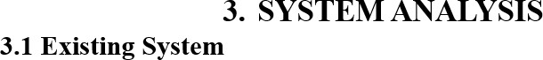

The authors in [11] conducted a review of several studies that employed consumer sleep technology (CST) integrated with machine learning algorithms (MLAs) for sleep classification. They observed that polysomnography (PSG) remains the gold standard for sleep assessment; however, it is costly and requires complex manual configurations managed by specialists to accurately classify sleep stages. Although CST has been utilized to monitor sleep, PSG continues to demonstrate higher accuracy in sleep stage classification. The reviewed literature encompassed 27 studies employing a range of MLAs, including logistic regression (LR), decision trees (DT), support vector machines (SVM), and deep learning models.
- Many existing methods rely on manual annotation of sleep stages or patterns, a process that is both labor-intensive and susceptible to human error. The inherent subjectivity of manual labeling introduces inconsistencies, thereby diminishing model accuracy.
- Sleep data exhibits significant variability between individuals, influenced by factors such as age, lifestyle, and health conditions. Traditional approaches often struggle to generalize across heterogeneous populations, leading to suboptimal performance when applied to diverse demographic groups.
- Existing systems often depend on expensive and specialized equipment, such as polysomnography (PSG) machines, which may not be readily accessible in all healthcare settings, limiting scalability and widespread adoption.
- Many legacy models lack the capability to process and analyze large-scale datasets efficiently, resulting in slower prediction times and reduced responsiveness in real- time applications.
- Conventional techniques frequently exhibit limited adaptability to evolving datasets, as they may require complete retraining when new data types or formats are introduced, thereby increasing maintenance costs and complexity.

3.2 PROPOSED SYSTEM:
The proposed study is driven by the need to address challenges arising from sleep disorders

in modern society, particularly among individuals already affected by such conditions. Sleep- related disorders pose a major public health concern, exacerbated by the influence of contemporary lifestyles and the general underestimation of adequate sleep as a critical necessity. As sleep is a fundamental determinant of human health, the application of machine learning techniques for sleep disorder classification becomes imperative to safeguard well- being and quality of life.
To achieve this, the system leverages machine learning algorithms such as the Voting Classifier and Gradient Boosting to enhance prediction accuracy. These models are implemented to classify sleep disorders more effectively, with the aim of improving both diagnostic reliability and clinical decision-making.
- The proposed system integrates advanced methods, including deep learning, to autonomously extract and prioritize the most significant features from sleep data. This approach eliminates the necessity for manual feature engineering, thereby increasing both efficiency and classification accuracy.
- The incorporation of large, diverse training datasets alongside robust machine learning algorithms enables superior generalization across varied populations and conditions, mitigating the risk of overfitting.
- The system is designed for scalability, capable of processing extensive volumes of sleep data from multiple sources, and adaptable to various clinical settings. By harnessing cloud computing resources and optimized data processing algorithms, it ensures high scalability without compromising performance.

- Since the architecture integrates multiple algorithms, it allows future extension by plugging in other ML or DL models (e.g., Random Forest, XGBoost, or Deep Neural Networks) without major rework.
- The system is capable of analyzing user-input URLs in real-time and immediately classifying them as safe, phishing, or spoofing, making it practical for real-world cybersecurity applications.
- The system evaluates performance with accuracy, confusion matrix, and classification reports, providing a detailed understanding of system strengths and weaknesses for further optimization.

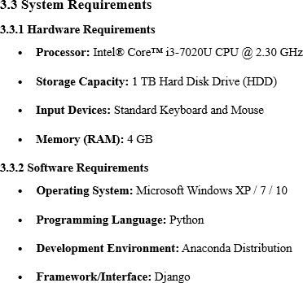

3.3 Feasibility Analysis
A critical outcome of the preliminary investigation is the determination of the feasibility of the system request. Feasibility is assessed based on the available resources, time constraints, and technical capacity of the organization. The analysis is carried out under the following dimensions:

Operational Feasibility
Operational feasibility assesses the likelihood of the system functioning effectively in the intended environment. The proposed system aims to automate administrative tasks, thereby minimizing manual effort and enabling efficient project tracking. This automation will significantly reduce both the time and energy spent on routine tasks. The study confirms that the system is operationally viable and aligns with the organization’s workflow requirements.

Economic Feasibility
Economic feasibility, or cost–benefit analysis, evaluates whether the proposed system is financially justifiable. As the organization already possesses the required hardware infrastructure, the additional project cost remains minimal. Since the system is network- based, any employee connected to the LAN can access it without incurring extra connectivity costs. Furthermore, the Virtual Private Network (VPN) component will be developed using existing organizational resources. Hence, the project is deemed economically viable.

Technical Feasibility
The evaluation of technical feasibility determines if the organization has adequate technical capabilities and infrastructure to successfully develop and launch the system. The

implementation requires IBM-compatible machines equipped with graphical web browsers, supporting both Internet and Intranet connectivity. The solution is designed to operate in a platform-independent environment, utilizing technologies such as Java Server Pages (JSP), JavaScript, HTML, SQL Server, and WebLogic Server. Based on the current infrastructure, the system is deemed technically feasible for development and can be implemented using the available facilities.

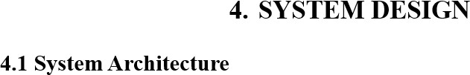
The System Design Document outlines the comprehensive specifications and architectural framework of the proposed system. This phase defines the system’s technical requirements, execution environment, architectural design (both overall and subsystems), data structures, database schema, input and output formats, user interaction mechanisms, processing workflows, and external system interfaces. This documentation serves as a blueprint for implementation, ensuring that all components of the system operate cohesively and efficiently.

4.2 Modules
In this module, the Service Provider must authenticate by entering valid credentials (username and password). Upon successful authentication, the Service Provider can perform the following operations:
- Login to the system.

- Train and test sleep disorder datasets.

- Visualize accuracy results for trained and tested datasets using bar charts.

- Predict sleep disorder types based on the trained model.

- View statistical ratios of different sleep disorder types.

- Download predicted datasets for further analysis.

Monitor and manage registered remote users.

View and Authorize Users:
The administrator can review the list of all registered users, view their details (including username, email address, and residential address), and grant authorization for system access.

4.2.2 Remote User Module
This module is designed for multiple remote users. The workflow includes:
- User Registration: New users must register before accessing system functionalities. User information is recorded in the database during the registration process.
- Authentication: After registration, users log in using their authorized credentials.

Functionalities Post-Login:
  - Register and log in.
  - Predict the type of sleep disorder.
  - View personal profile information.

4.2.3 Methodology
The system’s methodology focuses on data segmentation, model selection, and optimization:

Dataset Splitting:

  - The dataset is initially split into a training set (80%) and a pre-training set (20%).
  - The pre-training set is further divided into pre-train (80%) and pre-test (20%) subsets.
  - The training set undergoes further division into a train set (80%) and a

validation set (20%).

  - The train set is again split into train (80%) and test (20%) subsets, ensuring all sets are non-overlapping.

Model Selection:

  - The pre-train set is used to identify the most suitable models for the dataset.

  - The top four performing models are selected based on mean absolute error
(evaluated on the pre-test set).

Hyperparameter Optimization:

  - The selected models undergo hyperparameter tuning to determine the optimal configuration.

System architecture refers to the conceptual framework that defines the structure, behavior, and various perspectives of a system. An architecture description is a formal and structured representation that facilitates reasoning about the system’s organization and operational processes.

The three-tier architecture, also known as the three-layer model, was introduced in the 1990s as an improvement over the traditional two-tier framework. In this structure, a middle- tier server is added between the client-side interface and the data storage layer to enhance system performance and scalability. This middle tier is responsible for process management, execution of business logic and rules, and supporting scalability. Unlike the two-tier model, which generally handles only about 100 users, the three-tier architecture is capable of supporting hundreds of simultaneous users by incorporating features like request queuing, application processing, and database staging.
The three-tier architecture is well-suited for distributed client–server systems that demand higher performance, flexibility, scalability, maintainability, and reusability. It also hides the complexity of distributed processing from the user, which has made it a popular choice for internet-driven and network-centric applications.
- Clear separation between functionality and presentation.

- Improved comprehension through distinct functional layers.

- Changes are restricted to well-defined components.

- Compatibility with web-based deployment.

- Enhanced network performance.

The proposed system follows a Three-Tier Architecture, which separates the application into three independent layers:

Presentation Layer (User Interface)

  - Provides interaction between the user and the system.

  - Remote users can register, log in, and view predictions of sleep disorders.

  - Service providers can log in, manage datasets, and view analysis results.

  - Ensures that users interact through a simple, intuitive interface without needing to understand the underlying logic.

Application Layer (Business Logic / Processing Layer)

  - Acts as the core of the system, handling all functional operations.

  - Responsibilities include:

    - Managing login and authentication.

    - Uploading, training, and testing datasets.

    - Executing machine learning models for sleep disorder prediction.

    - Generating outputs such as accuracy metrics and prediction ratios.

  - This layer ensures all computations and workflows remain independent of the database and UI.

Database Layer (Data Storage Layer)

  - Stores user details, datasets, training/testing results, and prediction outputs.

  - Provides secure retrieval of processed datasets for further use.

  - Maintains system logs and user activity records.

  - Ensures data integrity and persistence, supporting both service providers and remote users.
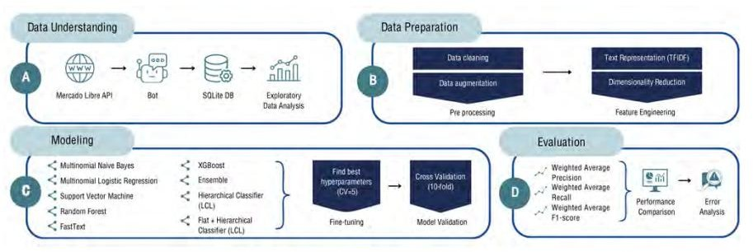

Figure 4. 1 System Architecture
It provides a high-level overview of the functional interactions between external entities, the central system, and major data flows.

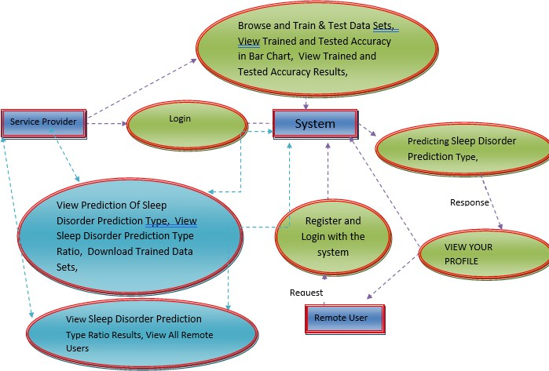

Figure 4. 2 Data Flow Diagram

External Entities:

  - Service Provider – Responsible for initiating the login process and performing core system operations.
  - Remote User – Interacts with the system primarily for registration, login, and profile-related activities.

Core Processes:

- Login – Facilitates authentication for both the service provider and remote users.
- Browse and Train & Test Data Sets – Allows the service provider to upload datasets, train and test models, and view results, including accuracy metrics displayed in bar chart form.
- Prediction of Sleep Disorder Type – Executes the model to determine the category of sleep disorder and presents the prediction ratio.

- View and Download Trained Data Sets – Enables the retrieval of processed datasets for external use.
- View All Remote Users – Provides administrative oversight of user activity.

Interactions:

- The Service Provider logs in, accesses dataset training/testing functionalities, views predictions, and manages remote user data.
- The Remote User registers, logs in, views predictions, and accesses their profile.
- The System acts as the central hub, processing requests, executing predictions, and returning results to both external entities.
This Level 0 diagram effectively captures the overall system scope, illustrating the primary data exchanges between actors and the central processing unit without delving into detailed internal workflows.

Flow Diagram

Flowchart – User Login & Prediction Flow
The flow diagram illustrates the overall process flow of the system, beginning with the Start node and progressing to the Login interface. Upon entering credentials, the system verifies the Status of the login attempt.
      - If the credentials are correct, the user proceeds to the Register and Login stage, where system functionalities become accessible. The user can then perform Sleep Disorder Prediction, view the predicted results, and access the View Your Profile section. From there, the user may continue using the application or choose to Logout.
      - If the credentials are incorrect, the system displays an error message indicating that the Username & Password combination is invalid, prompting the user to attempt login again.
This diagram effectively models the logical decision-making and sequential operations of the system, ensuring clarity in user navigation and process execution.

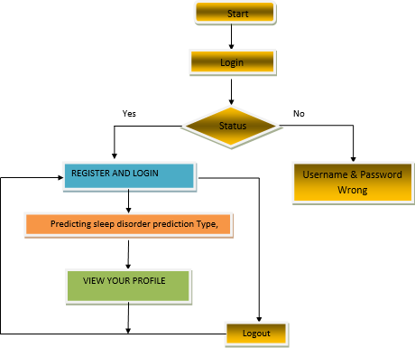

Flow Diagram-Dataset Training & Prediction Flow
The flow diagram represents the sequential operations and decision-making process within the system. The workflow initiates at the Start node, leading directly to the Login stage. Upon entering credentials, the system evaluates the Status of the login attempt.
- If the login is unsuccessful, the system displays a message indicating Username & Password Wrong, prompting the user to reattempt the login process.
- If the login is successful, the user gains access to the system’s core functionalities,
beginning with the option to Browse and Train & Test Data Sets.
- After dataset training and testing, the user can View Trained and Tested Accuracy in a Bar Chart and View Trained and Tested Accuracy Results.
- Subsequently, the system enables Prediction of Sleep Disorder Type, along with viewing the Sleep Disorder Prediction Type Ratio.
- The user is also able to Download Trained Data Sets and further examine Sleep Disorder Prediction Type Ratio Results.
- Additionally, the user can access the View All Remote Users feature for broader data insights.
The process concludes with the option to Log Out, at which point the workflow can either
terminate or restart based on the user’s interaction.

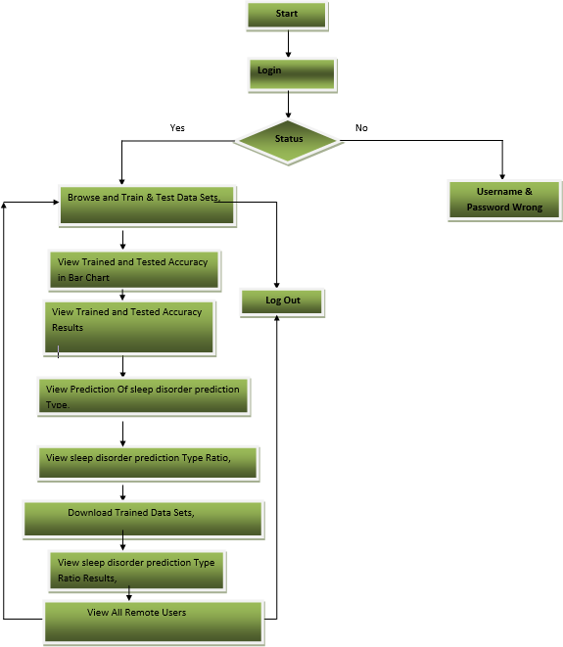

UML Diagrams

In a system, an actor represents the role of a user or an external entity. Although actors interact with the system, they do not directly control its use cases.

Actor

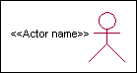
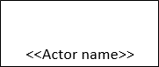
Actor Definition:
An actor is any entity, human or non-human, that:

- Interacts with the system by providing inputs and receiving outputs.

- Exists outside the system boundary without controlling its use cases.

Identifying Actors:
Actors can be identified by considering:
- Users who operate the system.

- Entities that maintain the system.

- External hardware connected to it.

- Other systems that interact with it.

Key Questions for Identifying Actors:
- Which users or groups need the system to complete their tasks?
- Which users influence the system’s operations?
- Which external systems or hardware, if any, interact with it?
- What problems does the system solve, and for whom?
- How do users perform actions or tasks within the system (use cases)?

Identified Actors in the System:
  - System Administrator – Responsible for managing, configuring, and maintaining the system.
  - Customer – End-user who interacts with the system to access services or features.
  - Customer Care Representative – Supports customers by addressing queries, issues, and providing assistance through the system.

Identification of Use Cases:
A use case describes a specific manner in which the system is utilized from the perspective of an actor.

Graphical Representation:

A use case can be characterized as:
  - A behavioral pattern exhibited by the system.

  - A chain of related interactions taking place between an actor and the system.

  - A procedure that provides a concrete result or benefit to the actor.

Purpose of Use Cases:
  - Capture and document system requirements.

  - Facilitate communication with end users and domain experts.

  - Support system testing and validation.

Guidelines for Identifying Use Cases:
  - For each actor, determine the tasks and functions they need to perform or that the system requires them to perform.
  - A use case represents a sequence of actions that achieve a well-defined objective.

  - Assign meaningful names to each use case.

  - Describe each use case in clear, user-friendly terms to reduce ambiguity.

Key Questions for Identifying Use Cases:
  - What tasks and responsibilities are assigned to each actor?

  - Does any actor need to create, modify, delete, or access system data?

  - Which use cases are responsible for performing these operations?

  - Should an actor notify the system about unexpected external events?

  - Must the system send notifications to actors regarding specific events?

  - Which use cases ensure system upkeep and maintenance?
It describes in detail what the system must perform, without focusing on how the tasks are implemented. These flows are usually recorded as independent documents or text files, which can later be associated with a specific use case through the Files tab of the related model element.
A well-structured flow of events should include:
- The conditions under which the use case begins and ends.
- The interactions between the use case and the actors.
- The data necessary for performing the use case.

- The standard or normal sequence of events in the use case.
- Any alternative or exceptional flows that may occur.

Construction of Use Case Diagrams
In the Unified Modeling Language (UML), a use case diagram is a behavioral diagram derived from use case analysis. Its primary objective is to provide a visual representation of the system’s functionality, illustrating the interactions between actors, their objectives (depicted as use cases), and any dependencies that may exist among these use cases.
The diagram helps map system functions to specific actors, making their roles and responsibilities within the system clear.
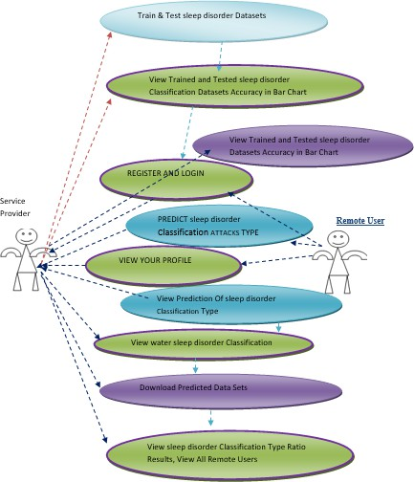

Figure 4. 3 Use Case Diagram
In UML, a sequence diagram is an interaction diagram that shows how processes communicate and the sequence of their interactions. Closely related to a Message Sequence Chart, it is also known as an event, scenario, or timing diagram. Its main purpose is to
demonstrate the system’s dynamic behavior by mapping the flow of events.

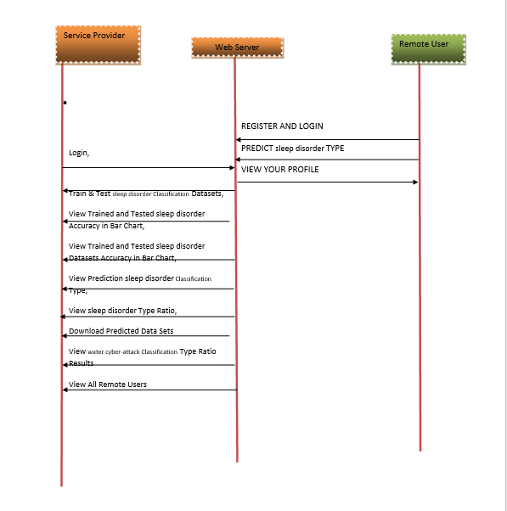
Figure 4. 6 Sequence diagram

4.6.3 Class Diagrams
Within the field of software engineering, a class diagram in UML represents a static structure diagram that defines the architecture of a system. The diagram presents the system’s classes with their attributes, operations, and inter-class relationships. Class diagrams provide a
detailed overview of the system’s data model, specifying which classes encapsulate specific
information and how they interact with one another.

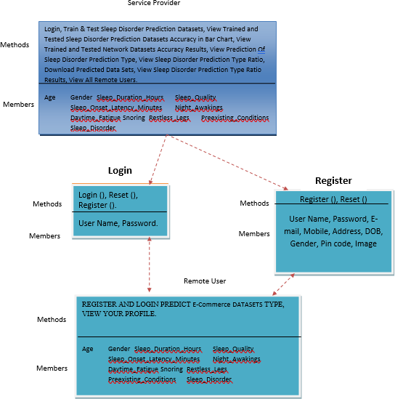

Figure 4. 7 Class Diagram

4.6.4 Activity Diagrams
An activity diagram is a graphical representation of workflows, illustrating step-by-step activities and actions with provisions for decision-making, iteration, and concurrent processes. In UML, activity diagrams are used to model both business processes and operational workflows of system components. They provide a high-level view of the flow of control and the sequence of actions, enabling clear visualization of process logic.

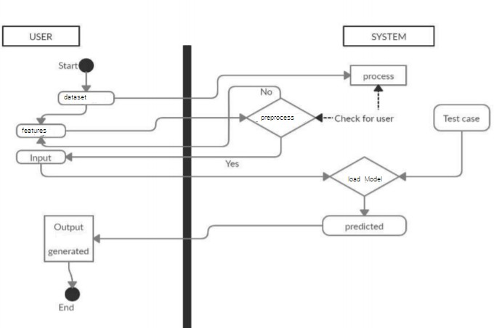
Figure 4. 8 Activity Diagram

IMPLEMENTATION

MODULES
    - Data Collection:
A custom dataset is created, containing features (e.g., tweet data) and corresponding labels indicating whether the content is forensic-related or not.
    - Data Preprocessing:
      - Features are stored in the x_train variable, and labels are stored in the y_train variable.
      - Standard scaling is applied to normalize the features.

      - The dataset is partitioned into training and testing portions: x_train/y_train for training, and x_test/y_test for performance evaluation.
      - The training data is fed into multiple algorithms, and performance metrics (accuracy) are calculated for each model.
    - Model Initialization and Training:
      - Machine learning algorithms (e.g., logistic regression and other classifiers) are initialized and trained on the dataset.
      - Trained models are serialized and stored as pickle files for future predictions.
    - Prediction Stage:
      - New input data is preprocessed and passed to the prediction function.
      - The trained model is loaded from storage, and predictions are generated and displayed via the web application.

Algorithms
Support Vector Machine (SVM) is a supervised algorithm used for tasks

involving classification and regression. It works by finding the optimal hyperplane that separates data points of different classes with the maximum margin. Kernel functions allow it to handle non-linear data effectively. SVM is widely applied in text classification, image recognition, and biomedical signal analysis.
The Random Forest algorithm builds several decision trees and combines their outputs to deliver more precise predictions. It reduces overfitting by using bootstrapped datasets and random feature selection. RF is robust to noise and performs well on both classification and regression tasks. It is particularly effective when dealing with large datasets with many variables.
5.2.3 Multilayer Perceptron (MLP) Classifier:
MLP is a type of feedforward artificial neural network consisting of input, hidden, and output layers. Each neuron uses an activation function to capture complex patterns in data. It is trained using backpropagation to minimize error. MLPs are powerful for non-linear classification tasks such as speech, image, and medical data analysis.
KNN is a simple instance-based learning algorithm that classifies data based on the majority label of its nearest neighbors. K, which specifies the number of neighbors, determines the smoothness of the decision boundary. It is non- parametric and easy to implement, though computationally expensive for large datasets. KNN is often used in recommendation systems, pattern recognition, and anomaly detection.

CODE
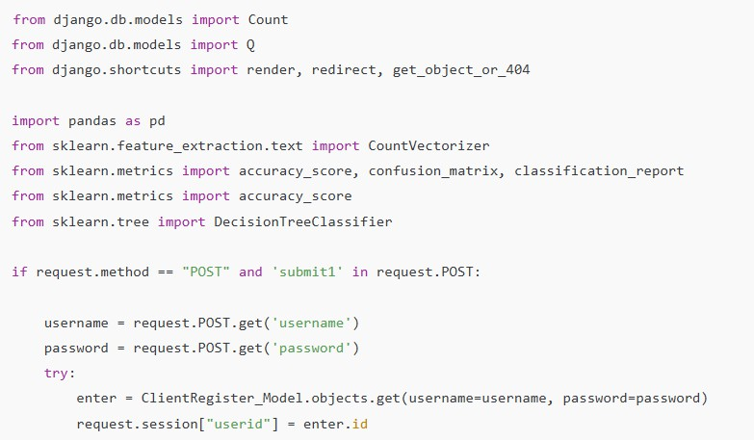
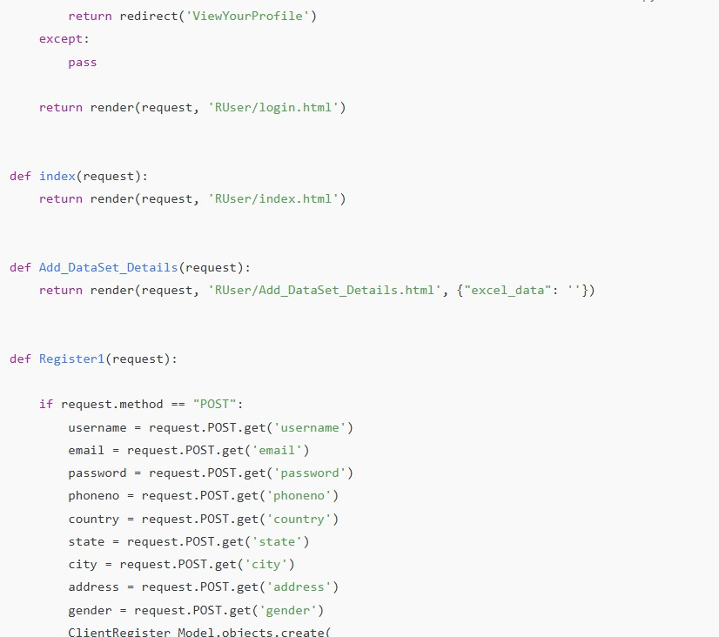

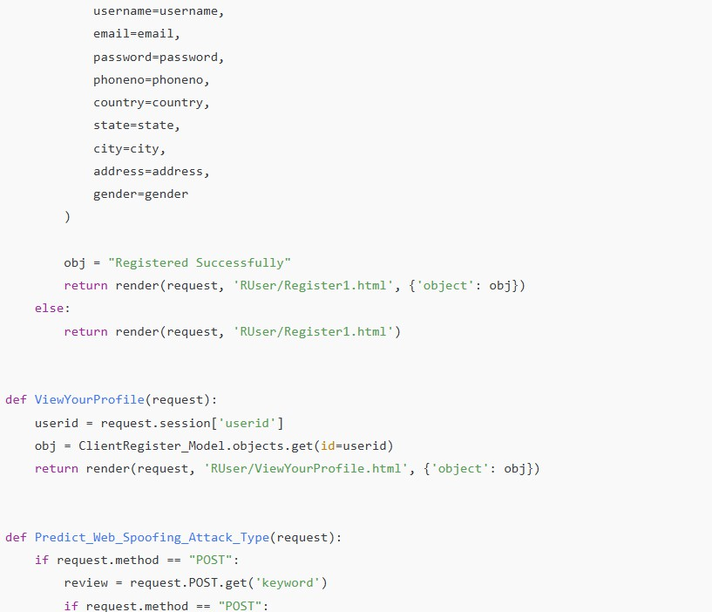
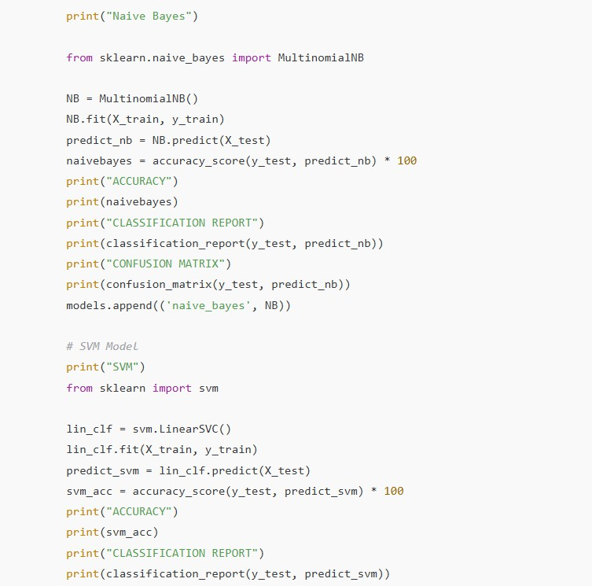

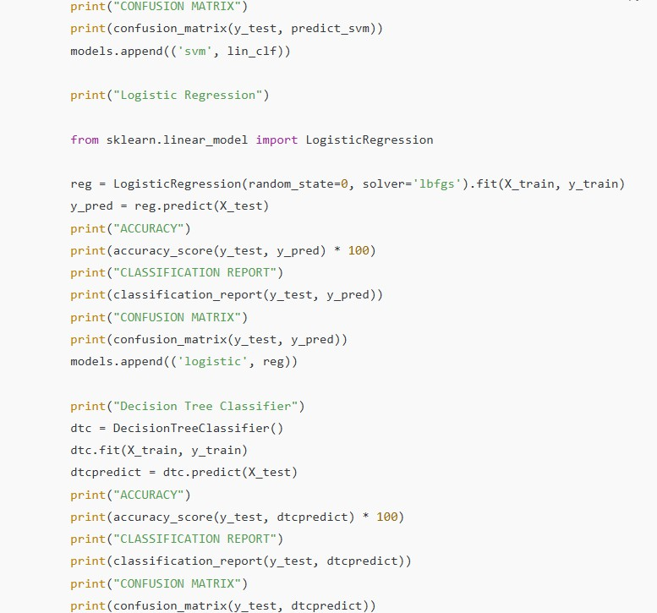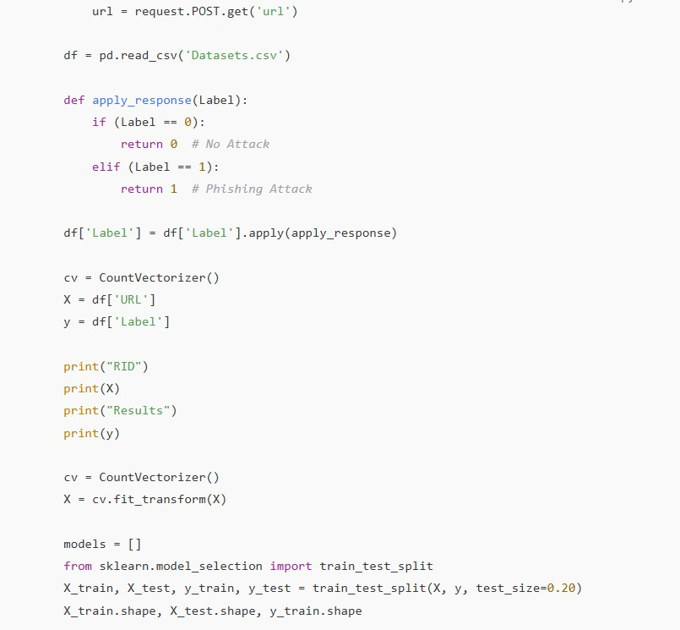

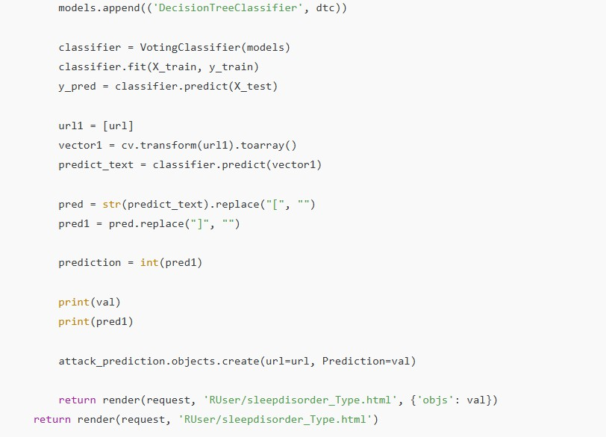

- SOFTWARE ENVIRONMENT

Anaconda is an open-source Python and R distribution widely used in data science, machine learning, and large-scale analytics. Created by Anaconda, Inc., it streamlines package management and deployment across Windows, Linux, and macOS.

Jupyter Notebook
Jupiter Notebook is an interactive environment that supports code executions,visualizations, and documentations whining a single interface. This is used in this project for data exploration, algorithm testing, and result visualization.

6.2 Python libraries Used

NumPy (import numpy as np)
NumPy provides essential functionality for performing scientific calculations in Python. It provides:
- A powerful n-dimensional array object (ndarray).
- Advanced mathematical functions, linear algebra routines, statistical tools, and Fourier transforms.
- Fixed-size arrays with homogeneous data types for memory efficiency.
- Optimized performance through compiled code execution.

Pandas (import pandas as pd)
Pandas, built on NumPy, is a high-level data manipulation library. Its primary data structure, the DataFrame, stores tabular data in rows and columns, enabling efficient data cleaning, transformation, and aggregation.

Matplotlib (import matplotlib)
Matplotlib is a 2D plotting library for visualizing arrays. It supports a wide range of plots including line, bar, scatter, and histograms, providing clear graphical representations of large datasets.

Seaborn (import seaborn as sns)
Seaborn, built on Matplotlib, is a library for creating statistical graphics. It integrates seamlessly with Pandas DataFrames and offers high-level functions for producing attractive and informative statistical graphics.

Scikit-learn (import sklearn)

Scikit-learn is a comprehensive ML library that supports:
- Supervised learning: classification and regression tasks.
- Unsupervised learning: clustering, density estimation, and dimensionality reduction.•
Model evaluation through built-in scoring functions and cross-validation tools.

Imbalanced-learn (import imblearn)
The imbalanced-learn library addresses class imbalance problems by implementing techniques such as:
- Random undersampling: removing majority class samples.
- Random oversampling: duplicating minority class samples.
These methods help mitigate bias toward the majority class, improving model fairness and predictive accuracy.

import tensorflow as tf
- In TensorFlow, developing a machine learning model typically involves defining, saving, and restoring the model.
- A model is conceptually:
  - A function that performs computations on tensors (forward pass)
  - A collection of variables that are updated during training
- This guide goes beyond the Keras high-level API to explore how TensorFlow models are defined internally, how variables and models are managed, and how saving and restoring operations are performed.

from tensorflow.keras import layers, models, optimizers, callbacks, regularizers, metrics
- A Sequential model is suitable for a simple stack of layers where each layer has exactly one input tensor and one output tensor.
- It is not suitable if:
  - Multiple inputs or outputs are necessary for the model.
  - Any individual layer processes multiple inputs or outputs
  - Layer sharing is necessary
  - A non-linear topology is needed (e.g., residual connections or multi-branch structures)

from sklearn import metrics
- The accuracy_score metric evaluates the percentage of accurate predictions made by the model.

- In multi-label classification tasks, this function calculates subset accuracy, meaning the predicted label set for each instance must match the corresponding true label set exactly.

6.3 Technologies Used
- Python – Main programming language.
- Django – Web framework (presence of manage.py, apps.py, views.py, models.py, etc.).
- SQLite / SQL – Database (Classification_of_Sleep_Disorders.sql).
- HTML5 – For web pages (index.html, login.html, ratings.html, etc.).
- CSS – For styling (login.css).
- JavaScript (likely embedded) – Since .html files often contain validation
/ dynamic functionality.
- SWF (Flash files) – button1.swf, text1.swf (though Flash is outdated)

Testing is one of the most crucial stages in software development, ensuring that the system performs its intended functions accurately and reliably. Without proper testing, the system may fail to produce the expected outputs, regardless of how well it was designed.
Testing involves using representative data to identify and correct errors or bugs before the system goes live. The focus is on the quality of test data rather than its quantity. End-user involvement during testing can greatly enhance the process, as users can help uncover issues that developers might overlook.
The main objectives of system testing are:
- To uncover as many errors as possible with minimal effort and time.

- To create test cases that have a high probability of detecting errors, if they exist.

- To verify that the system meets quality and reliability standards.

- To ensure that the software behaves as specified under all expected conditions.

A successful test is one that reveals a previously undetected error, while inadequate testing risks allowing errors to remain unnoticed.

7.2 Levels of Testing
- Code Testing
Code testing focuses on examining the program’s logic. It verifies whether individual components, such as data update routines and directory handling, function correctly using sample files and data.ink
- Specification Testing
Specification testing ensures that the system behaves as defined in its specifications. Test cases are prepared for various scenarios and combinations of conditions across all modules to confirm that the software performs as expected under each situation.

Unit testing checks individual software modules in isolation to confirm they function correctly and deliver expected outputs before system integration.
During this phase, field-level validation checks are also performed to verify the correctness of user inputs. For example, the system is tested to ensure it rejects invalid data formats and accepts only valid entries. Detecting and fixing errors at this stage is easier and less costly.
Unit testing can be carried out using two primary strategies:
- Black Box Testing – Focuses on the input-output behavior of the module without considering its internal logic.
- White Box Testing – Examines the internal structure and logic of the code to ensure that all paths and conditions are correctly implemented.

Black Box Testing is a technique that evaluates a system’s functionality based on its requirements and specifications, without considering the internal code, structure, or execution. It focuses only on inputs and their corresponding outputs.

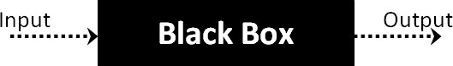

This method applies to diverse systems—such as operating systems, websites, databases, or custom applications—by evaluating behavior through inputs and outputs without examining internal code.

Steps in Black Box Testing
The standard process for conducting Black Box Testing typically includes the following steps:
Review Requirements and Specifications – Examine the documented requirements and specifications of the system to understand its expected behavior.
- Select Test Inputs – Identify valid inputs (positive test scenarios) to verify correct system processing, and invalid inputs (negative test scenarios) to confirm proper error handling.

- Determine Expected Outputs – Define the correct output for each chosen input.

- Determine Expected Outputs – Specify the correct output for every selected input.
- Design Test Cases – Create well-structured test cases that include inputs and their expected results.
- Execute Test Cases – Run the designed test cases on the system under test.
- Compare Results – Match the actual outputs with the expected outputs to verify correctness.
Black Box Testing includes several types, with the most common being:
Functional Testing – Focuses on verifying the functional requirements of a system to ensure that it performs as intended. This type is typically conducted by software testers.
- Non-Functional Testing – Evaluates non-functional aspects of the system, such as performance, scalability, and usability, which are not directly related to specific functionalities.
- Regression Testing – Performed after updates like bug fixes, upgrades, or maintenance to confirm that existing features remain unaffected by recent change.

Definition
White Box Testing is a software testing methodology that evaluates the internal structure, coding, and infrastructure of a software solution The primary aim is to validate how inputs and outputs flow within the application, while also improving security, design, and usability. This method is commonly referred to as structural testing, clear box testing, glass box testing, or open box testing.
White Box Testing forms one of the two major approaches to software testing, the other being Black Box Testing. While Black Box Testing assesses the system from an external, end-user perspective without visibility into the internal workings, White Box Testing examines the system from within, analyzing its code and logic. The phrase “white box” conveys the idea of transparency, allowing the tester to examine the internal structure of an application beyond its external interface.

Verification Areas in White Box Testing
White Box Testing is performed to assess the following aspects of a software system:
  - Detection of internal security flaws

  - Identification of broken or poorly designed code paths

  - Verification of the routes followed by particular inputs within the code

  - Confirmation of expected output results

  - Assessment of the accuracy of conditional loops

  - Individual testing of statements, objects, and functions

White Box Testing can be conducted at different stages of software development, such as unit testing, integration testing, and system testing. Its primary goal is to ensure that the internal logic and flow of the application operate correctly. If a given input does not generate the expected output, the resulting inconsistency is treated as a defect or bug.

Procedure for White Box Testing
The process of conducting White Box Testing typically involves the following two key steps:
The tester starts by carefully examining and comprehending the application’s source code. Since this approach requires analysis of the internal logic, the tester needs to be proficient in the programming languages employed in the application. Moreover, knowledge of secure coding practices is essential, as White Box Testing frequently focuses on identifying and addressing potential security risks, such as malicious code injections by attackers or accidental vulnerabilities introduced by users.

Step 2 – Creating and Executing Test Cases
Once the code is understood, the tester designs and executes test cases to validate its structure and logic. In many cases, additional code may be written to test existing code segments, a process that is often performed by developers themselves. Each process or set of processes within the application is tested systematically. Testing methods may include:
  - Automated test scripts

  - Manual code walkthroughs

  - Trial-and-error approaches

  - Use of specialized testing tools

7.5 Unit testing Results
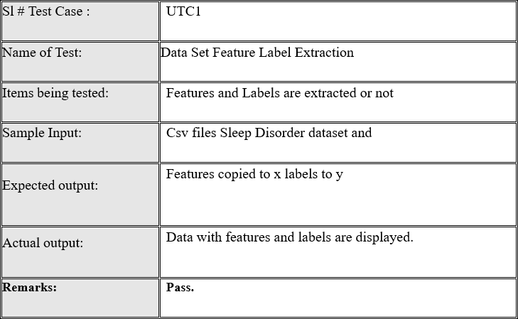
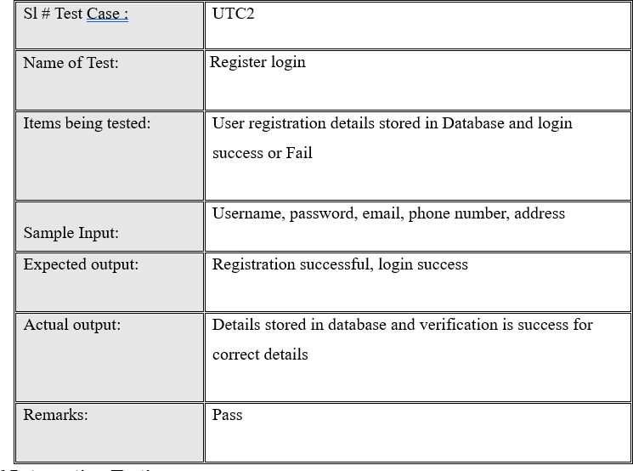

Integration testing consists of merging individual software modules and checking their collective functionality. Its main goal is to detect defects in the interactions between the integrated components. Test drivers and stubs are used to support this testing process.

Typically, integration testing is performed after unit testing and prior to validation testing. Integration testing can be carried out using the following approaches:

Bottom-Up Integration
In this approach, testing begins with unit testing of the lowest-level modules, followed by the integration and testing of progressively higher-level modules or builds.

Top-Down Integration
In this method, testing starts with the top-level modules and proceeds by integrating and testing lower-level modules step by step. Generally, bottom-up testing is performed initially, followed by top-down testing. The process concludes with comprehensive testing of the entire application, preferably under conditions that closely simulate real-world scenarios.
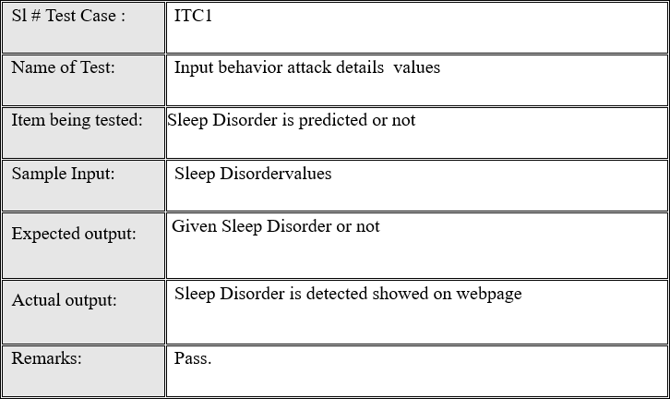

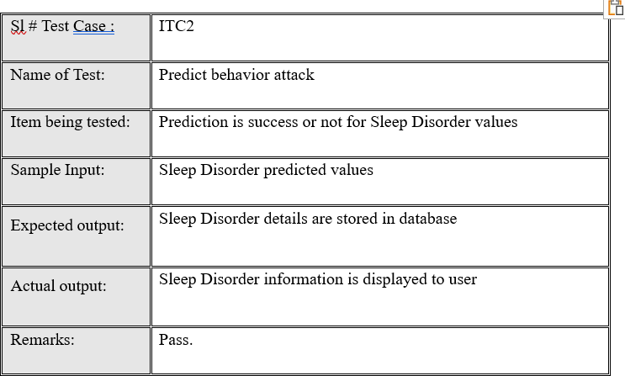
System testing involves evaluating a fully integrated software or hardware system to verify its compliance with the specified requirements. It is typically performed as part of black-box testing, meaning it does not require any knowledge of the system’s internal code structure or logic.
- In the Software Development Life Cycle, system testing represents the first stage in which the entire application is tested collectively.
- The application undergoes extensive testing to ensure it satisfies both functional and technical requirements.
- Testing is conducted in an environment that closely resembles the actual production setting where the application will be deployed.
- System testing allows for the verification and validation of both business requirements and the underlying application architecture.

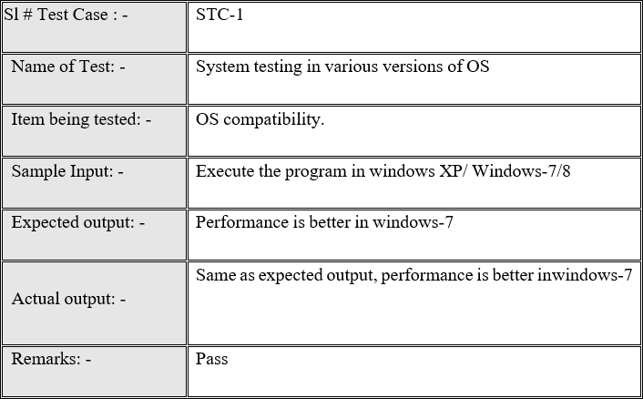

OUTPUT

  - Home Page

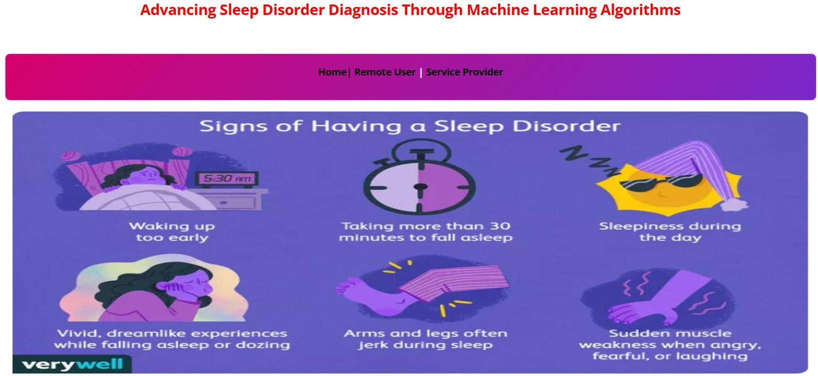
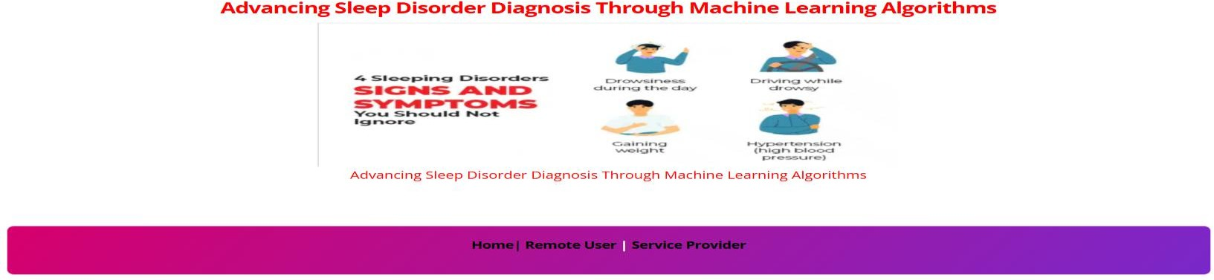

  - User Login
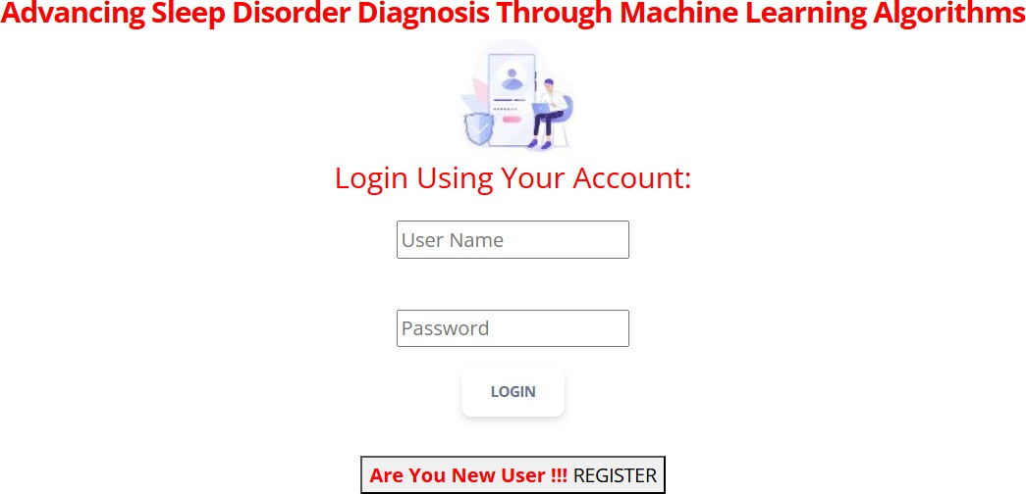

  - Prediction Inputs
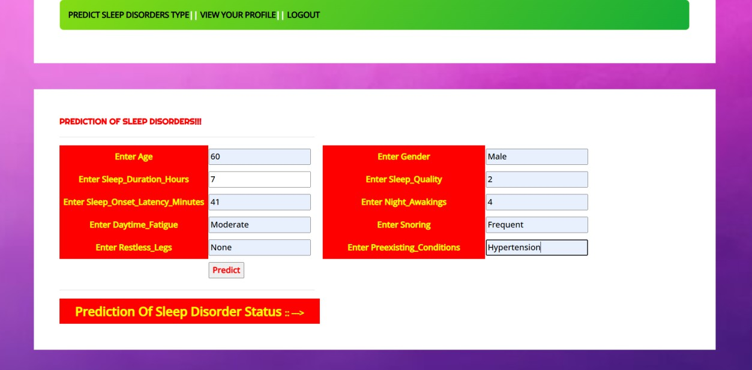

  - Prediction Results

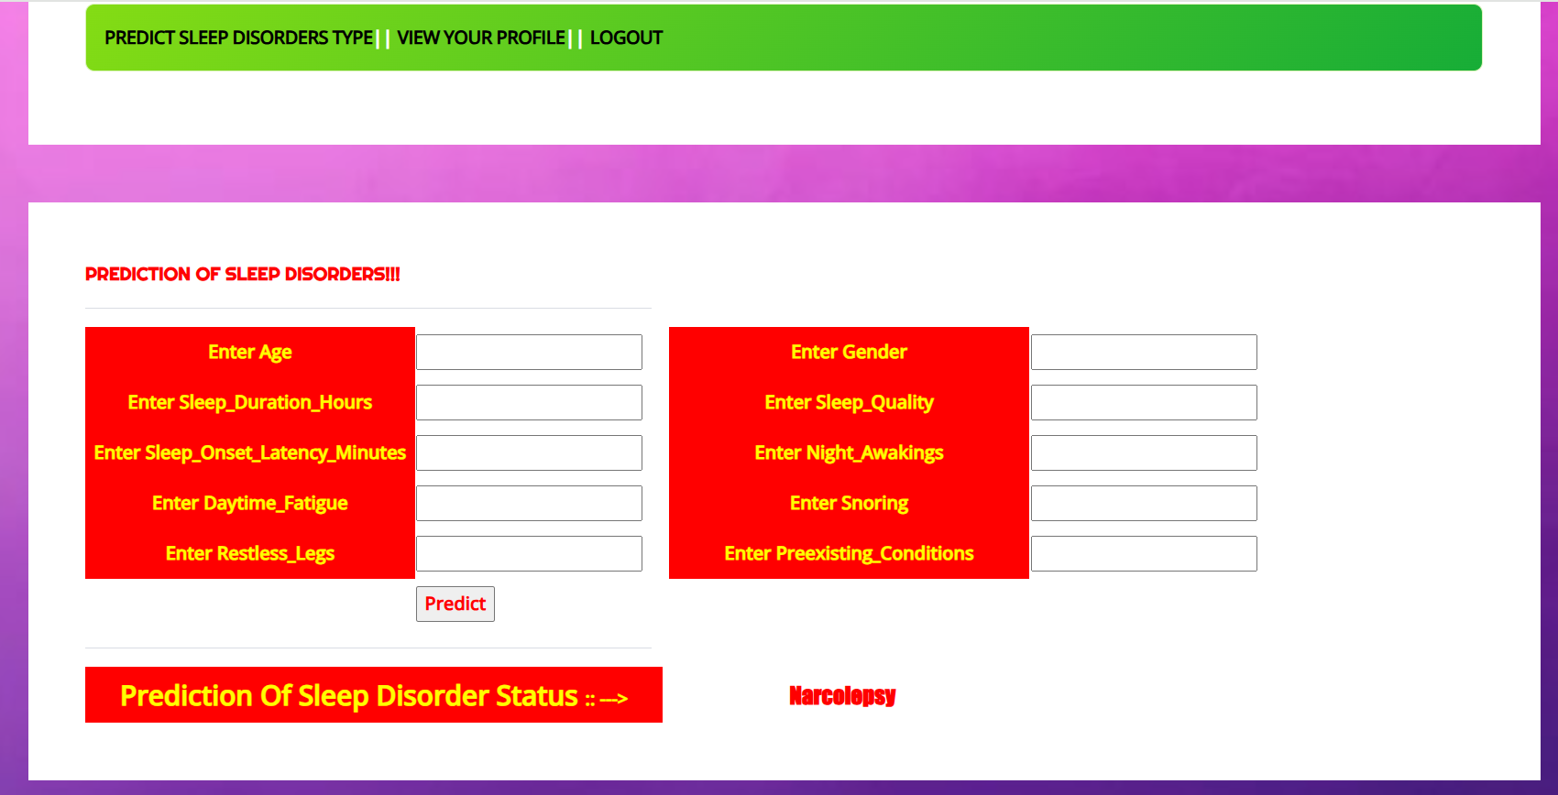

  - Service Provider Login



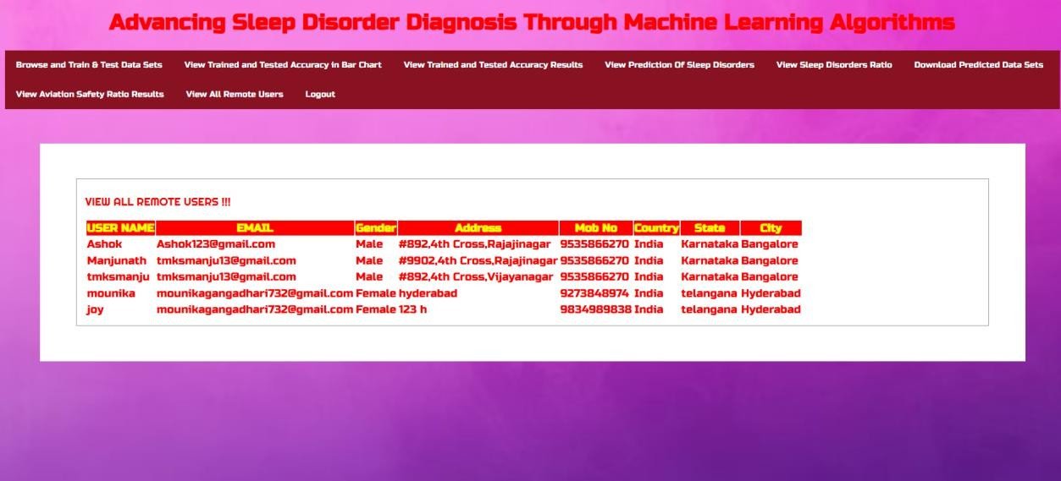

CONCLUSION
In e-commerce, an efficient and scalable product classification system is crucial for enhancing search relevance, product discoverability, and user experience. Traditional hierarchical systems, while accurate, often struggle with scalability and complexity, making them less suitable for large, rapidly changing product catalogs.
The proposed flat-hierarchical model—leveraging KNN, Logistic Regression (LR), Random Forest Classifier (RFC), Voting Classifier, and Gradient Boosting (GB)— provides a robust alternative by combining the simplicity of flat classification with the predictive power of machine learning. This approach streamlines the classification process, improves adaptability to new product types, and reduces reliance on manual categorization. By utilizing diverse ML techniques, the system achieves higher classification accuracy, faster prediction speeds, and better capacity to adjust, ultimately ensuring improved efficiency and
automated e-commerce cataloging solution.

Future Work
Future improvements can focus on:
    - Deep Learning & Transformers – Integrating advanced architectures like BERT, RoBERTa, or Vision Transformers for better semantic and visual understanding.
    - Multimodal Classification – Combining text, image, and metadata for richer product context and improved classification accuracy.
    - Real-Time Learning – Implementing feedback loops to enable self-improvement and reduce retraining needs.
    - Reinforcement Learning – Using adaptive strategies to classify entirely new product types.
    - Explainable AI (XAI) – Adding transparency to model decisions to improve trust and compliance.

REFERENCES
- V. Gupta, H. Karnick, A. Bansal, and P. Jhala, “Product classification in e-commerce using distributional semantics,” The COLING 2016 Organizing Committee, 2016.
- P. Das et al., “Large-scale taxonomy categorization for noisy product listings,” 2016.
- V. Umaashankar, G. S. S, and A. Prakash, “Atlas: A dataset and benchmark for e- commerce clothing product categorization,” arXiv:1908.08984, 2019.
- Z. Kozareva, “Multi-class product categorization for e-commerce,” Association for
Computational Linguistics, 2015.
- J. W. Ha, H. Pyo, and J. Kim, “Large-scale item categorization in e-commerce using
multiple recurrent neural networks,” ACM SIGKDD, 2016.
- R. M. Pereira, Y. M. Costa, and C. N. Silla, “Handling imbalance in hierarchical classification problems,” Data Mining and Knowledge Discovery, 2021.
- E. Lehmann et al., “Bilingual transfer learning for online product classification,” ACL,
2020.
- W. Zhang et al., “Deep hierarchical product classification based on pre-trained
multilingual knowledge,” IEEE Bulletin of the Technical Committee on Data Engineering,
2021.
- I. Hasson et al., “Category recognition in e-commerce using sequence-to-sequence
hierarchical classification,” WSDM 2021.
- F. Liu et al., “MEP-3M: A large-scale multi-modal e-commerce product dataset,” Pattern
Recognition, 2023.-
- O. Ozyegen et al., “Classifying multi-level product categories using dynamic masking
and transformer models,” Journal of Data, Information and Management, 2022.
- T. M. Tashu et al., “Multimodal Sleep Disorder using hierarchical fusion,” 2022.
- Q. Chen et al., “Two-stream hybrid attention network for multimodal classification,”
ICIP 2021.
- C. N. Silla and A. A. Freitas, “A survey of hierarchical classification across different application domains,” Data Mining and Knowledge Discovery, 2011.

Turnitin Originality Report
Processed on: 26-Aug-2025 16:36 IST ID: 2735536221
Word Count: 6777
Submitted: 1

Advancing Sleep Disorder Diagnosis Through Ma... By MOUNIKA
GANGADHARI 23011F0059
Document Viewer

Similarity Index
14%
Similarity by Source

Internet Sources: 6%
Publications: 6%
Student Papers: 10%

include quoted include bibliography excluding matches < 15 words mode:
quickview (classic) report print refresh download

3% match (student papers from 25-Aug-2025) Class: PG THESIS
Assignment: Thesis Paper ID: 2734927187

1% match (student papers from 22-Aug-2025) Class: PG THESIS
Assignment: Thesis Paper ID: 2733291229

1% match (student papers from 22-Dec-2023) Class: PG THESIS
Assignment: Thesis Paper ID: 2263978115

1% match (publications)
R. N. V. Jagan Mohan, B. H. V. S. Rama Krishnam Raju, V. Chandra Sekhar, T. V. K. P. Prasad. "Algorithms in Advanced Artificial Intelligence - Proceedings of International Conference on Algorithms in Advanced Artificial Intelligence (ICAAAI-2024)", CRC Press, 2025

1% match (student papers from 06-Dec-2018)
Submitted to University of Southern California on 2018-12-06

<1% match (student papers from 12-Aug-2025) Class: PG THESIS
Assignment: Thesis Paper ID: 2728599086

<1% match (student papers from 22-Aug-2025) Class: PG THESIS
Assignment: Thesis Paper ID: 2733297050

<1% match (student papers from 19-Aug-2025) Class: PG THESIS
Assignment: Thesis Paper ID: 2731861599

<1% match (Internet from 03-Jul-2025)
https://www.mdpi.com/2076-3417/14/16/7231

<1% match (publications)
Shravan Pargaonkar. "A Guide to Software Quality Engineering", CRC Press, 2024

<1% match (Internet from 09-Aug-2025) http://itegam-jetia.org

<1% match (Internet from 21-Aug-2024)

https://www.qatouch.com/blog/blackbox-vs-white-box-testing/

<1% match (publications)
Shankar Babu, Mahesh Babu Kota. "Synergies in Smart and Virtual Systems using computational intelligence", CRC Press, 2025

<1% match (student papers from 12-May-2005)
Submitted to University of Central England in Birmingham on 2005-05-12

<1% match (Internet from 19-Nov-2023)
https://turcomat.org/index.php/turkbilmat/article/download/14155/10187/25220

<1% match (student papers from 14-Oct-2024)
Submitted to Centre for Distance and Online Education Galgotias University on 2024-10-14

<1% match (Jayalakshmi Murugan, K Sai Vamsi, K.Dheeraj Datta Reddy, K.Pavan Chand,
K.Mohammed Feroz. "Navigating College Campuses with Virtual Assistants", 2023 International Conference on the Confluence of Advancements in Robotics, Vision and Interdisciplinary
Technology Management (IC-RVITM), 2023)
Jayalakshmi Murugan, K Sai Vamsi, K.Dheeraj Datta Reddy , K.Pavan Chand, K.Mohammed Feroz. "Navigating College Campuses with Virtual Assistants", 2023 International Conference on the Confluence of Advancements in Robotics, Vision and Interdisciplinary Technology
Management (IC-RVITM) , 2023

<1% match (Internet from 01-Jun-2023) https://polynoe.lib.uniwa.gr/xmlui/bitstream/handle/11400/4425/0014-
%20%ce%9c%ce%94%ce%95%20-%20Sign%20Language%20Detection.pdf?
isAllowed=y&sequence=1

<1% match (publications)
Raj K. Keservani, Sayan Bhattachary y a, Rajesh K. Keservani. "Nutraceuticals in Insomnia and Sleep Problems", Apple Academic Press, 2025

<1% match (Internet from 27-Oct-2024)
https://eitca.org/wp-content/uploads/materials/eitca_exam_mat_eitc-ai-mlp.pdf

<1% match (student papers from 20-Jan-2025) Submitted to Anna University on 2025-01-20

<1% match (Internet from 19-Dec-2024)
https://medium.com/@keployio/understanding-white-box-testing-an-in-depth-guide- 0cd763195e09

<1% match (Internet from 02-Jul-2025)
https://www.jenrs.com/publications/JENRS_0406001.pdf

<1% match (student papers from 03-Oct-2006)
Submitted to (school name not available) on 2006-10-03

<1% match (student papers from 02-Jul-2025)
Submitted to Jawaharlal Nehru Technological University Kakinada on 2025-07-02

<1% match (Internet from 24-Jan-2025) https://ijirt.org/publishedpaper/IJIRT164483_PAPER.pdf

<1% match (Internet from 03-Aug-2025)
https://www.isteonline.in/Datafiles/cms/2025/IJTE%20Spl%20issue%201%20June%202025%20%281%29.p

<1% match (student papers from 15-May-2023)
Submitted to Southern New Hampshire University - Continuing Education on 2023-05-15

<1% match (Internet from 24-Feb-2025) https://iccs.ac.in/assets/images/publication/Anveshan-2025.pdf

<1% match (Internet from 18-Aug-2024)
https://www.geeksforgeeks.org/unified-modeling-language-uml-class-diagrams/

<1% match (student papers from 06-Mar-2025)
Submitted to University of Huddersfield on 2025-03-06

<1% match (Internet from 26-Jul-2025)
https://eudoxuspress.com/index.php/pub/article/download/2004/1309/3768



International Journal of Computer Techniques – Volume 12 Issue 5, September - October - 2025
RESEARCH ARTICLE
.
OPEN ACCESS
Advancing Sleep Disorder Diagnosis Through Machine Learning Algorithms
G. Mounika
MCA Student, Department of Information Technology, Jawaharlal Nehru Technological University, India

************************

Abstract:
Sleep plays a vital role in maintaining physical and mental health, and disruptions in sleep patterns can lead to serious medical conditions. Accurate classification of sleep disorders is therefore essential for effective diagnosis and treatment. Traditional methods, such as manual annotation of polysomnography (PSG) data, are time-consuming, costly, and prone to human error, making them unsuitable for large-scale applications. This project proposes a machine learning–based system for the automatic classification of sleep disorders. The system leverages a curated sleep dataset, where features and labels are extracted and preprocessed for training. Multiple algorithms, including Logistic Regression, Random Forest Classifier, Gradient Boosting, K-Nearest Neighbors, and ensemble models, are implemented to evaluate performance. A Django-based interface is developed to enable user-friendly interaction, allowing seamless registration, login, and visualization of results.Experimental results demonstrate that the proposed approach significantly improves classification accuracy compared to traditional methods, ensuring consistent and reliable outputs. The system undergoes rigorous testing, including unit, integration, and system-level evaluations, to validate its functionality and robustness.Overall, the project reduces reliance on manual classification, enhances diagnostic efficiency, and provides a scalable solution for healthcare applications. This work highlights the potential of machine learning in advancing sleep disorder analysis and sets the foundation for future integration with real-time monitoring systems.

Keywords — Sleep-stage classification, machine learning, Automated diagnosis, Sleep quality
************************

INTRODUCTION
Sleep is a vital biological process essential for physical health, cognitive function, and overall well-being. Poor sleep quality increases accident risks and is linked to conditions like cardiovascular disease, diabetes, obesity, and psychological disorders. Polysomnography (PSG) remains the gold standard for sleep analysis but is costly, labor-intensive, and subjective. Surveys, including a 2021 Philips report, show rising global sleep problems, underscoring the need for automated solutions. Sleep is categorized into wakefulness, N1, N2, N3, and REM, with distinct physiological markers critical for diagnosis.
Machine learning (ML) and deep learning (DL) offer potential for automated classification, with ML relying on manual feature extraction while DL learns directly from raw data. However, challenges include dataset limitations, variability across populations, noise, and computational demands. This research aims to evaluate and compare traditional ML methods (e.g., LR, LDA, KNN, DT, SVM, RF) with DL models. The objective is to benchmark performance using standard datasets and metrics, identifying strengths and weaknesses of each approach.
Ultimately, this study seeks to propose an optimized framework that integrates ML and DL to improve
accuracy, efficiency, and generalizability in automated sleep-stage classification.

LITERATURE SURVEY
TABLE I
Focus Area | Methods / Data  Used | Key Findings
CST + ML for sleep- stage classification [11] | 27 studies; MLAs (LR, DT, SVM, DL); CST vs PSG | MLAs improved CST accuracy; PSG still gold standard; challenges with raw physiological signals
Sleep apnoea detection with ECG [12] | 48 studies; SVM, RF, DL on ECG signals | SVM and DL performed best; limited by ECG variability and small,  low-quality datasets
Sleep-stage classification with EEG [13] | 4 public datasets; CNN + BiLSTM on  EEG spectrograms | Achieved accuracies of 94.17%, 86.82%,  83.02%, 85.12%; CNN-  BiLSTM effective in capturing temporal & frequency features
OSA severity | 4,014 patients (non- | Accuracies: 88%, 88%,

International Journal of Computer Techniques – Volume 12 Issue 5, September - October - 2025
Admin
prediction [14] | public); Gradient Boosting, RF, K- means | 91%; efficient vs manual, but limited by single-centre bias &  missing values
Sleep apnoea detection (ECG) [15] | Apnoea-ECG dataset (70 records); CNN, LSTM, BiLSTM, GRU | Accuracies 74.72%–  84.13%; CNN-LSTM  best; DL can learn discriminative features better than MLAs
Sleep-stage classification [16] | ISRUC-Sleep dataset; DT, KNN, RF on  ECG features | RF > 90% accuracy, outperforming DT and  KNN
Sleep apnoea detection (ECG,hybrid) [16–17] | PhysioNet ECG Sleep Apnoea v1.0.0 (70 records); CNN + DRNN + PCA | Hybrid CNN–DRNN achieved superior accuracy; recommended for robust ECG-based apnoea detection

Interface and the User Interface.
Admin Interface
The service provider logs in with valid credentials, manages user accounts, monitors datasets, and oversees prediction logs through a secure dashboard.
  - Dataset Selection/Creation
The service provider prepares and securely stores a dataset containing sleep-related features (e.g., sleep duration, latency, fatigue, snoring, pre-existing conditions) along with corresponding labels (normal or disorder).
  - Data Preprocessing
Collected data undergoes cleaning, normalization (standard scaling), and feature extraction before being split into training and testing sets.
  - Model Training and Validation
Machine learning models (SVM, Random Forest, MLP, KNN) are trained, validated, and serialized for deployment, with performance evaluated using accuracy, precision, recall, and F1-score.
  - User Management
The admin reviews and authorizes registered users, manages their profiles, and tracks overall system activity. User Interface
Remote users register, log in, upload sleep-related data,

METHODOLOGY

- Proposed Work

The proposed study is driven by the need to address challenges arising from sleep disorders in modern society, particularly among individuals already affected by such conditions. Sleep-related disorders pose a major public health concern, exacerbated by the influence of contemporary lifestyles and the general underestimation of adequate sleep as a critical necessity. As sleep is a fundamental determinant of human health, the application of machine learning techniques for sleep disorder classification becomes imperative to safeguard well-being and quality of life.
To achieve this, the system leverages machine learning algorithms such as the Voting Classifier and Gradient Boosting to enhance prediction accuracy. These models are implemented to classify sleep disorders more effectively, with the aim of improving both diagnostic reliability and clinical decision-making.

- System Architecture
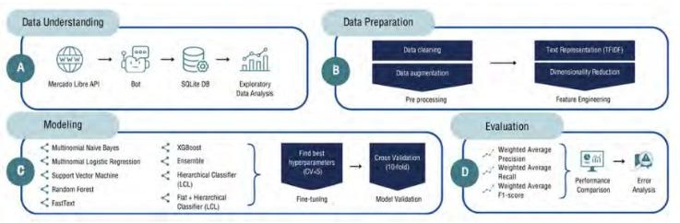
Fig. 1 System Architecture
This architecture consists of two main components: the
and receive disorder predictions with accuracy metrics and visual results.
  - Model Deployment
New data inputs are classified by the deployed model into categories such as normal or specific sleep disorder, with prediction results displayed through charts and statistical ratios.
  - Anomaly & Prediction System
The system detects abnormal patterns in input data, categorizes them into severity levels (low, medium, high), and generates alerts for early intervention.
  - Web Application Development
The application is built with Flask/Django (backend) and HTML, CSS, and Python libraries (frontend), featuring registration, login, data upload, prediction viewing, dataset downloads, and graphical history tracking.
  - Testing & Validation
Models are tested with real and synthetic datasets to validate accuracy, precision, recall, and F1-score, ensuring system reliability and robustness.
  - Algorithms Employed
    - Support Vector Machine (SVM): Separates classes using an optimal hyperplane, effective for both linear and non-linear data.
    - Random Forest (RF): An ensemble of decision trees that improves stability and reduces overfitting.
    - Multilayer Perceptron (MLP): A neural network that learns complex non-linear relationships through backpropagation.
    - K-Nearest Neighbours (KNN): Classifies input by comparing with the closest neighbors in the dataset.

International Journal of Computer Techniques – Volume 12 Issue 5, September - October - 2025

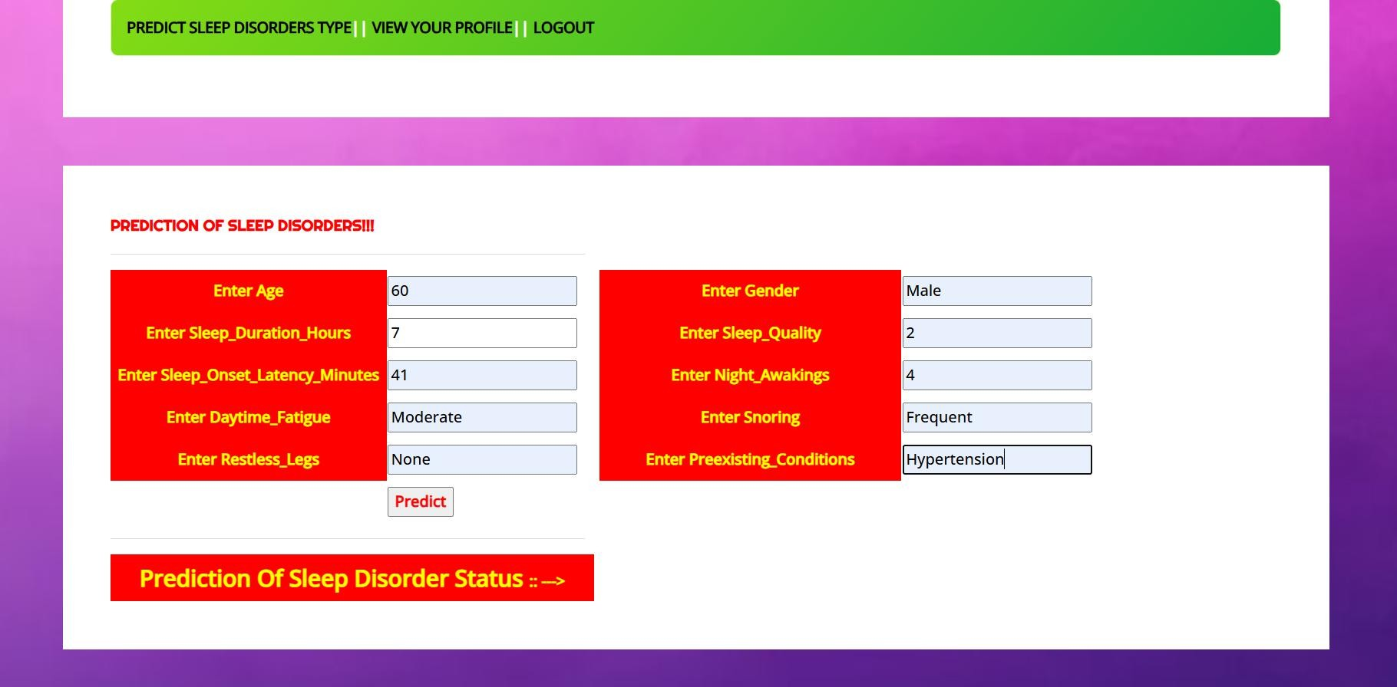
EXPERIMENTAL RESULTS
Open Anaconda Prompt
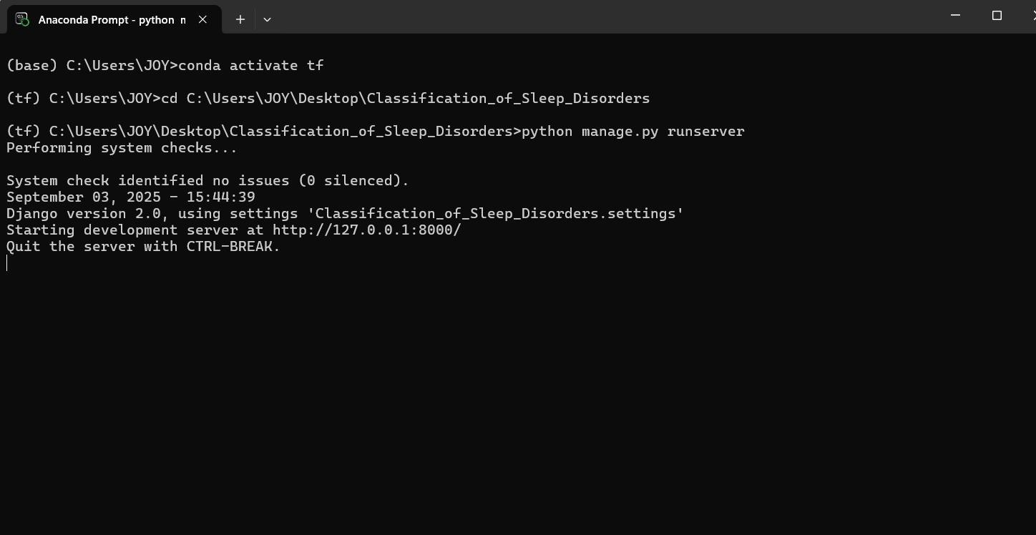
Switch to TensorFlow environment to run the file change to the directory where the file is located then run the file and open the URL http://127.0.0.1:8000/ by clicking ctrl+click.

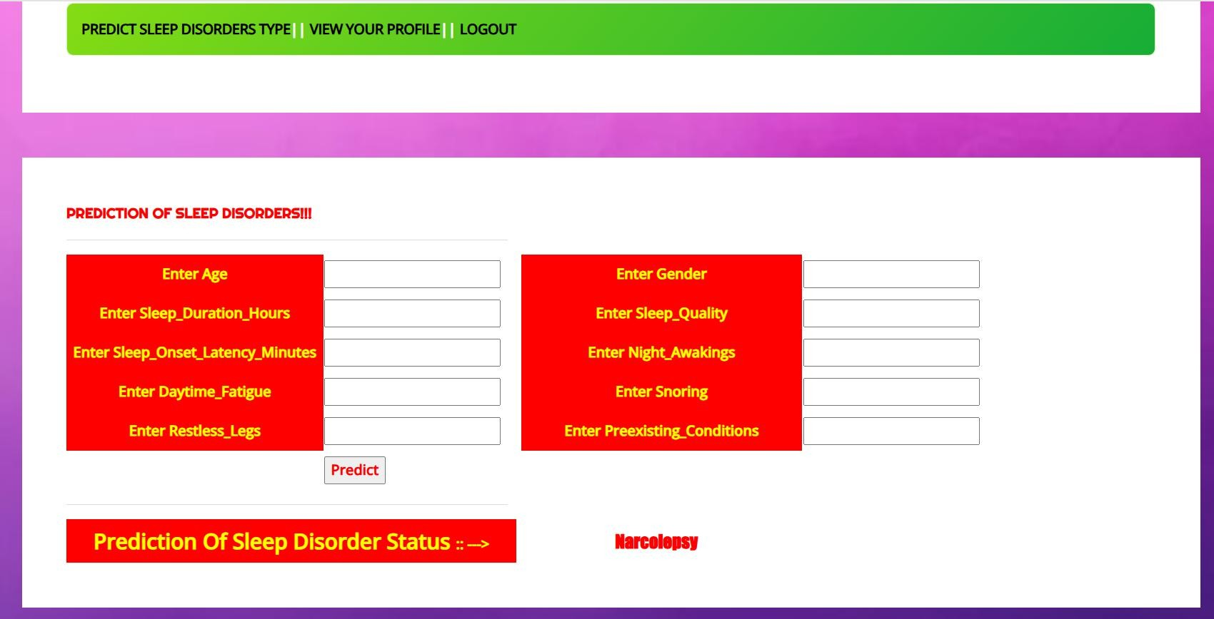
Fig. 5 Prediction Page

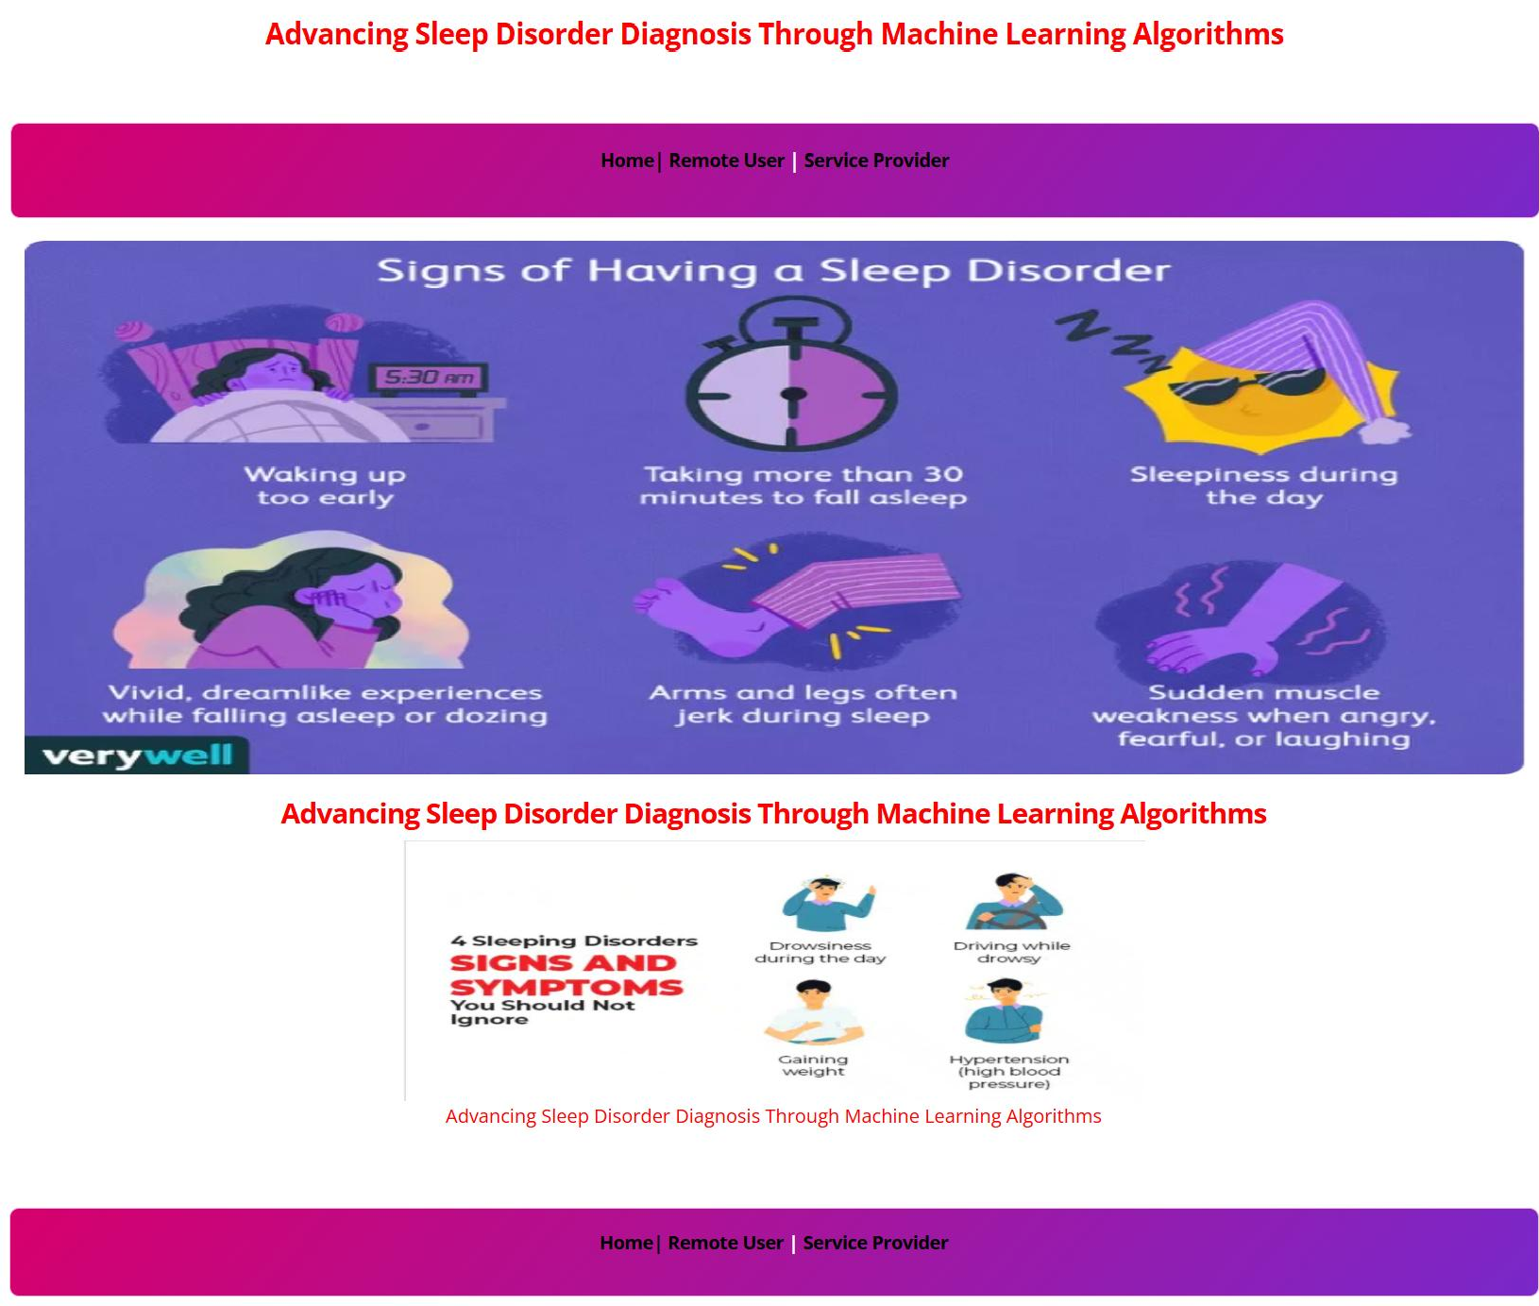
Fig. 2 Anaconda Prompt

Fig. 6 Prediction Results

Once user logs in user can view their profile, predict and logout. User can predict the data, and find out Sleep Disorder

Fig. 3 Home Page

This is the Home Page, it has three options Home, Remote User, Service Provider.

Fig. 7 Admin Login

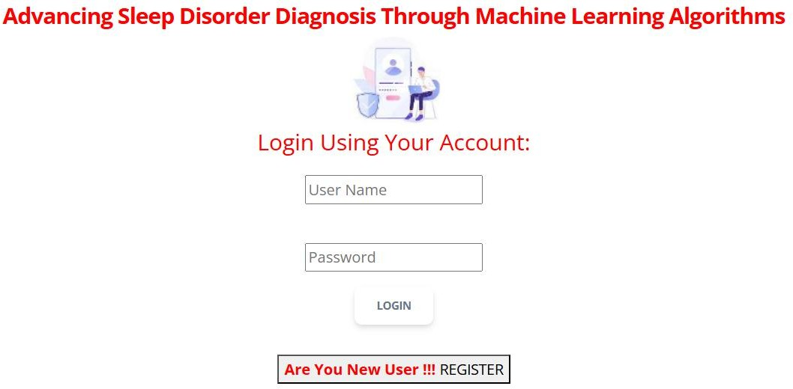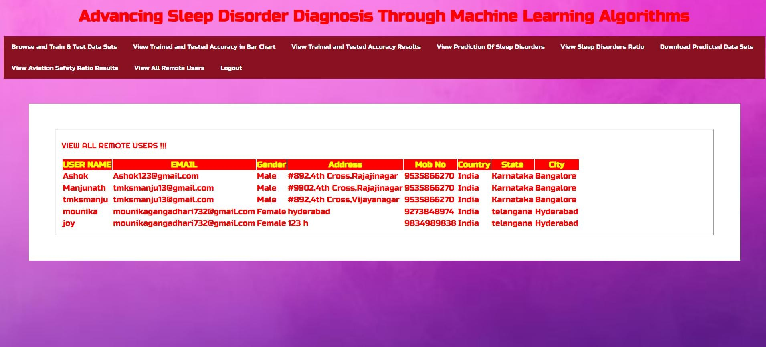

Fig. 4 User Login Page
This is User Login Page
Fig. 8 View User Profile
Once admin logs in he can manage the users data

International Journal of Computer Techniques – Volume 12 Issue 5, September - October - 2025
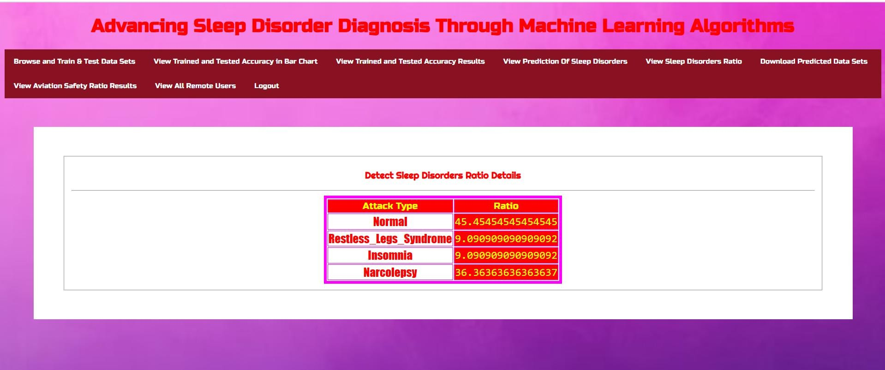
- Multimodal Classification – Combining text, image, and metadata for richer product context and
improved classification accuracy.
- Real-Time Learning – Implementing feedback loops to enable self-improvement and reduce retraining needs.
- Reinforcement Learning – Using adaptive strategies to classify entirely new product types.

Fig. 8 Model Accuracy

CONCLUSIONS
In e-commerce, an efficient and scalable product classification system is crucial for enhancing search relevance, product discoverability, and user experience. Traditional hierarchical systems, while accurate, often struggle with scalability and complexity, making them less suitable for large, rapidly changing product catalogs.
The proposed flat-hierarchical model—leveraging KNN, Logistic Regression (LR), Random Forest Classifier (RFC), Voting Classifier, and Gradient Boosting (GB)—provides a robust alternative by combining the simplicity of flat classification with the predictive power of machine learning.
This approach streamlines the classification process, improves adaptability to new product types, and reduces reliance on manual categorization.
By utilizing diverse ML techniques, the system achieves higher classification accuracy, faster prediction speeds, and better capacity to adjust, ultimately ensuring improved efficiency and automated e-commerce cataloging solution.

FUTURE SCOPE
Future improvements can focus on:
1. Deep Learning & Transformers – Integrating advanced architectures like BERT, RoBERTa, or Vision Transformers for better semantic and visual understanding.
- Explainable AI (XAI) – Adding transparency to model decisions to improve trust and compliance.

REFERENCES
- V. Gupta, H. Karnick, A. Bansal, and P. Jhala, “Product classification in e-commerce using distributional semantics,” The COLING 2016 Organizing Committee, 2016.
- P. Das et al., “Large-scale taxonomy categorization for noisy product listings,” 2016.
- V. Umaashankar, G. S. S, and A. Prakash, “Atlas: A dataset and benchmark for e-commerce clothing product categorization,” arXiv:1908.08984, 2019.
- Z. Kozareva, “Multi-class product categorization for e-commerce,” Association for Computational Linguistics, 2015.
- J. W. Ha, H. Pyo, and J. Kim, “Large-scale item categorization in e- commerce using multiple recurrent neural networks,” ACM SIGKDD, 2016.
- R. M. Pereira, Y. M. Costa, and C. N. Silla, “Handling imbalance in hierarchical classification problems,” Data Mining and Knowledge Discovery, 2021.
- E. Lehmann et al., “Bilingual transfer learning for online product classification,” ACL, 2020.
- W. Zhang et al., “Deep hierarchical product classification based on pre- trained multilingual knowledge,” IEEE Bulletin of the Technical Committee on Data Engineering, 2021.
- I. Hasson et al., “Category recognition in e-commerce using sequence-to- sequence hierarchical classification,” WSDM 2021.
- F. Liu et al., “MEP-3M: A large-scale multi-modal e-commerce product dataset,” Pattern Recognition, 2023.
- O. Ozyegen et al., “Classifying multi-level product categories using dynamic masking and transformer models,” Journal of Data, Information and Management, 2022.
- T. M. Tashu et al., “Multimodal Sleep Disorder using hierarchical fusion,” 2022.
- Q. Chen et al., “Two-stream hybrid attention network for multimodal classification,” ICIP 2021.
- C. N. Silla and A. A. Freitas, “A survey of hierarchical classification across different application domains,” Data Mining and Knowledge Discovery, 2011.

